

Department of Energy Engineering


3-Way Ball Valve

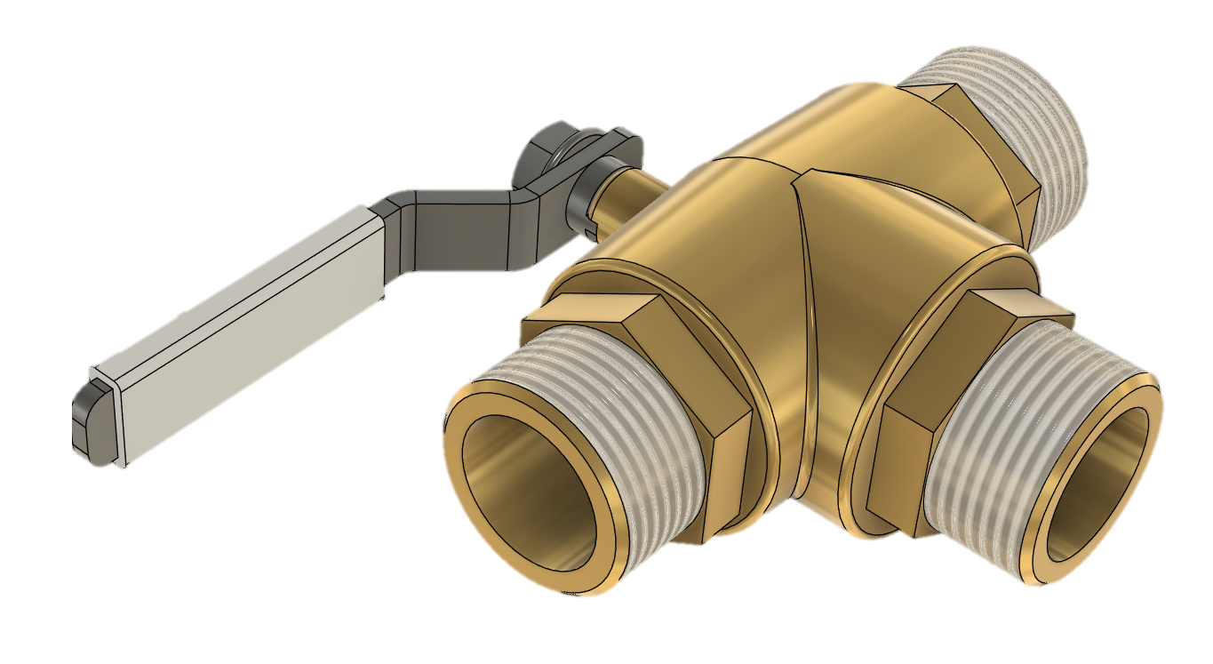

A cura di Giuseppe Salerno-Raffaele Montanarella
Anno accademico 2024/2025
Pag. 1 | 68
INDICE:
introduction 1
casting 2
Technical drawing of the central component 2.01
Permanent mold casting 2.02
Parting line and undercuts 2.03
Mold: machining allowances, draft angles, and fillets 2.04
Core 2.05
Cooling Moduli 2.06
Riser 2.07
Pouring Channel 2.08
Rain pouring system 2.09
Technical drawing of the mold 2.10
Inspire cast 3
Filling 3.01
Solidification time 3.02
Porosity and trapped air 3.03
3D PRINTING 4
Lever Cover 4.01
Process Advantages and Disadvantages 4.02
Pag. 2 | 68
Material 4.03
Process Flow 4.04
Printing Parameters 4.05
CHIP REMOVAL 5
CHIP REMOVAL 5.01
MACHINES 5.02
TOOLS 5.03
OPERATING SHAFT 5.04
EGULATING RING 5.05
PLASTIC DEFORMATION 6
SHEET METAL 6.01
ECCENTRIC PRESS 6.02
wELDING 7
MIG and MAG Classification 7.01
Stahlwerk MIG MAG 7.02
COMPONENTS TO BE PURCHASED 8
SPHERE 8.01
GASKET 8.02
nippLE 8.03
PROCESSING TIMES 9
Pag. 3 | 68
PROCESSING COSTS 10
RAW MATERIALS 10.01
ADDITIONAL COMPONENTS TO BE PURCHASED 10.02
MACHINES/TOOLS 10.03
3D REPRESENTATION 11
SOURCES 12

Pag. 4 | 68
INTRODUCTION

The three-way brass ball valve is a reliable and versatile solution for managing flow in piping systems, ideal for hydraulic, industrial, and domestic installations that require precise control. We have decided to produce 1,500 three-way ball valves for two main reasons:
- The first concerns the valve itself: its three-way configuration, which allows for flow diversion or complete shut-off, is not always required in installations, but it is essential for specific applications.
- The second reason relates to the production quantity: since this is a technically specific component made of brass—a material that offers greater strength and reliability, although it is more expensive compared to other alternatives (as we will see in the final part of this discussion)—we have chosen to limit production to 1,500 units. This allows us to target a more specific customer base with well-defined needs.
CASTING

We chose to manufacture the central body through casting, as it is the largest component within our assembly. This decision was made not only for structural reasons, but also to optimize costs and production times, reducing the number of necessary machining operations and improving the efficiency of the production process.
As for the material, we opted for brass, since, as previously mentioned in the introduction, it offers greater strength compared to cheaper materials, especially in terms of durability and corrosion resistance. Moreover, since the product is intended for a more demanding customer segment, brass provides a higher perceived value, enhancing the reliability and overall quality of the valve.
For the smaller components, we believe the best compromise between quality and price is 304 stainless steel. This material, thanks to its properties, is particularly suitable for domestic use, as it ensures good resistance to moisture and to many chemical agents. present in water and to mechanical wear. Moreover, the choice of 304 stainless steel allows us to maintain a good balance between durability, strength, and production cost, without compromising the overall quality of the product.
Pag. 5 | 68
TECHNICAL DRAWING OF THE CENTRAL COMPONENT

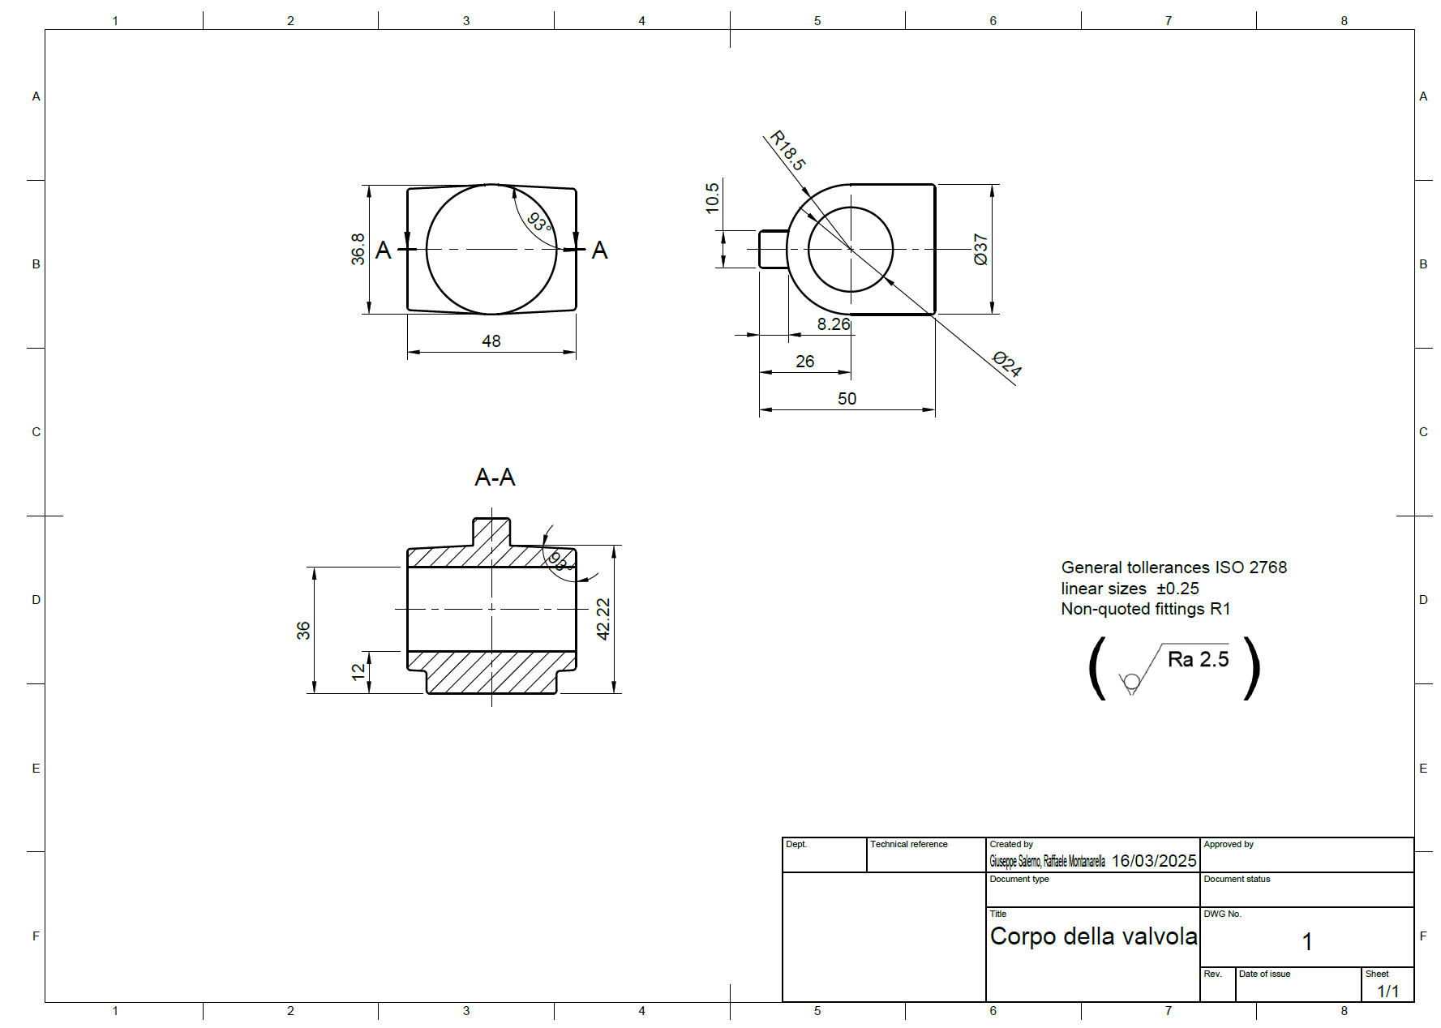

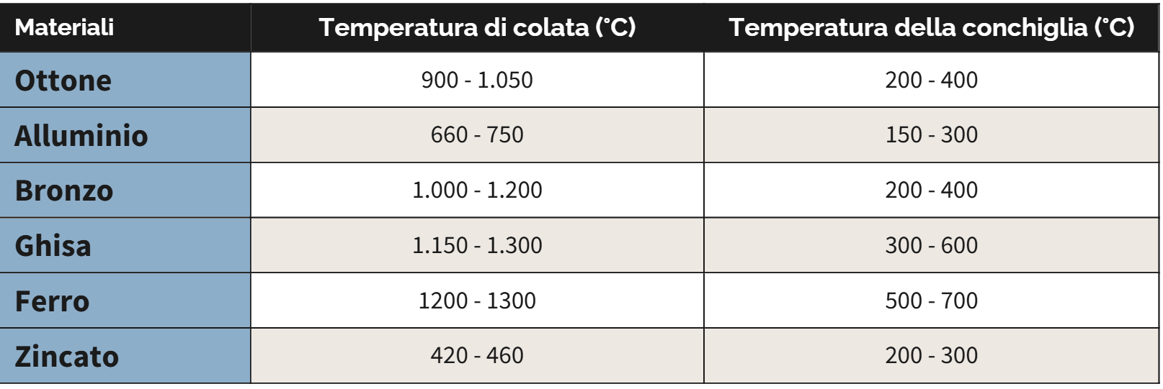

Il processo di fusione più adatto
Pag. 6 | 68
For the central piece, the most suitable casting process is, of course, permanent mold casting, as the mechanical component does not have particularly complex shapes. A total of 1,500 units are planned, as previously stated, so with the permanent casting process we will have the advantage of reusing the molds repeatedly, since they are made from durable materials such as steel. Although these molds are more expensive due to the materials used and the complexity of manufacturing, their durability allows for more cost-effective production, as it reduces the number of molds that need to be made.
PERMANENT MOLD CASTING

The permanent mold casting process is also particularly suitable for materials with high melting temperatures. As shown in the table above, brass has relatively high melting temperatures, reaching around 970°C (Santochi). This makes permanent mold casting ideal, as steel molds are designed to withstand such high temperatures without deteriorating.
Choosing permanent mold casting results in a more precise and less porous shape, reducing the likelihood of defects such as blowholes. However, trapped air can still cause imperfections, and to avoid this, venting channels are used to allow gases to escape during the pouring process.

PARTING LINE AND UNDERCUTS

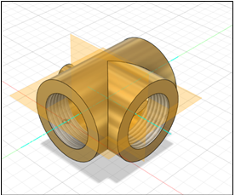
As can be seen from Figure 1.2 and the valve body drawing (Figure 1.3), since this is a casting blank with a not very complex shape, it features two planes of symmetry. We have chosen to consider the one that vertically cuts through the body, in order to facilitate demolding and the pouring of the brass. In this way, we will also avoid any issues related to undercuts.

Pag. 7 | 68
Figure 1.2 Isometric view of the valve body with planes of symmetry

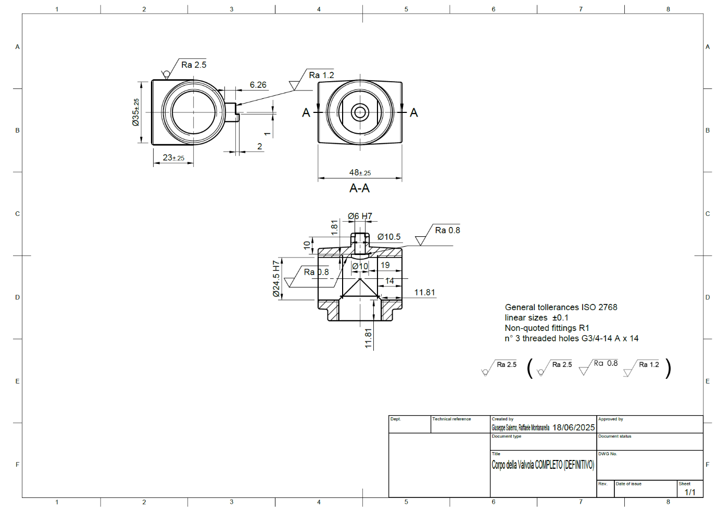

Figure 1.3 Drawing of the valve body

MOLD: MACHINING ALLOWANCES, DRAFT ANGLES, AND FILLETS

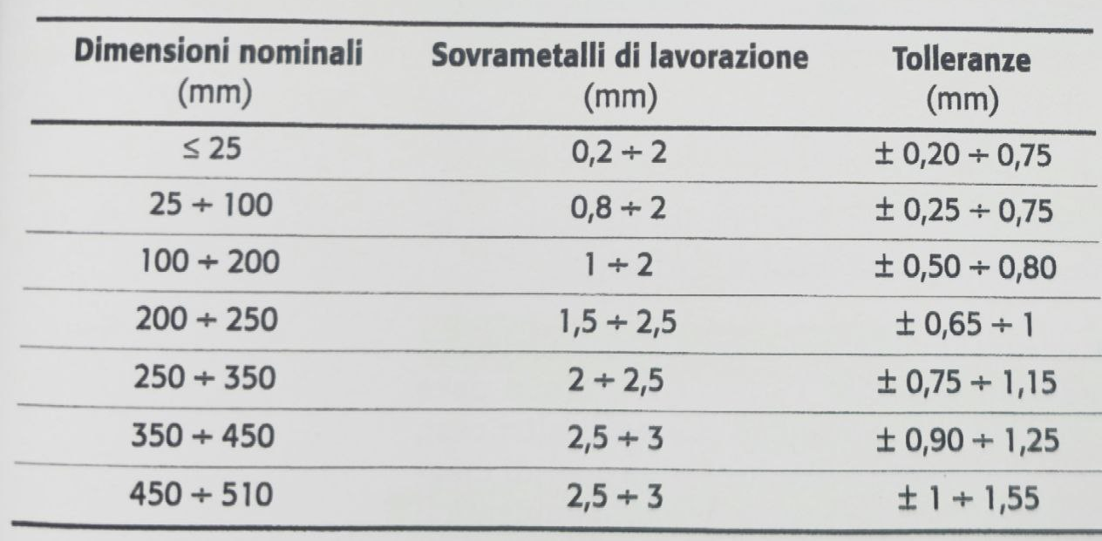
Figure 1.4 Table of average indicative values for machining allowances and achievable tolerances in the gravity permanent mold casting process (source: Santochi)
Pag. 8 | 68
Even with a simple-shaped casting blank, we could still face extraction issues from the permanent mold due to sharp edges and the shape of the part itself. For these reasons, we made a modification to the design, in order to solve these two problems. As shown in Figure 1.6, we added a 1 mm machining allowance to the circular surfaces with a 36 mm diameter, and a 0.5 mm allowance to the circular surface that will be drilled to accommodate the valve's actuating shaft. These decisions were made based on the data in Table 1.4.

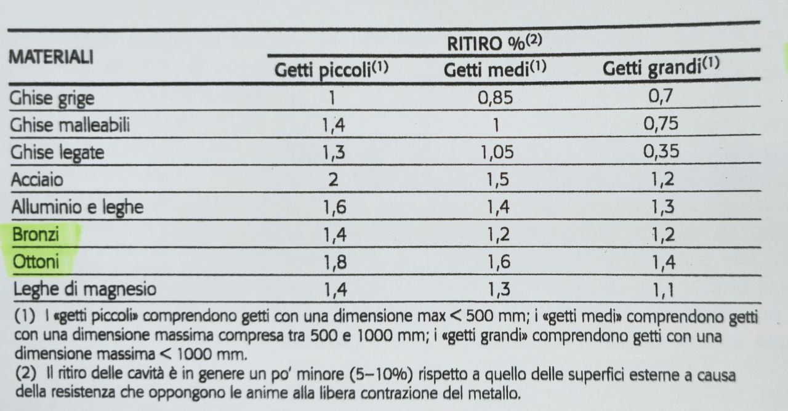

Figure 1.5 Table of average linear shrinkages of castings (source: Santochi))

Considering also Table 1.5, we estimated the average shrinkage of the casting. This allowed us to oversize the part compared to the original dimensions in order to address this issue. By setting up a simple algebraic equation, we find that, if r' is the linear shrinkage coefficient, x is the dimension of the casting (in mm) we need to achieve to avoid errors, and a is the original dimension (in mm) of the measurement in question, we obtain:
Pag. 10| 68
$$x_{1}\left(1-r'\right)=d_{1} => x_{1}=\frac{d_{1}}{1-r'}=\frac{36}{1-0.018}≅36.659878 mm$$
$$x_{2}\left(1-r'\right)=d_{2} => x_{2}=\frac{d_{2}}{1-r'}=\frac{10}{1-0.018}≅10.183299 mm$$
Since the lateral surfaces of the casting blank are not functional surfaces, we can approximate these values to 37 mm and 10.5 mm. In fact, since these are relatively small values, increasing them slightly will not significantly raise the volume of the blank, which would otherwise imply a higher amount of brass to be poured, but it will still ensure volumetric shrinkage does not compromise the functionality of the part.
To ensure trouble-free demolding, we also added fillets to all sharp edges of the blank and applied a 3° draft angle to the lateral surface of the central cylinder. Figure 1.7 provides an idea of the mold itself: the complete drawings of the mold with all relevant dimensions, tolerances, and surface finishes will follow, after the design of the riser and the gating system.

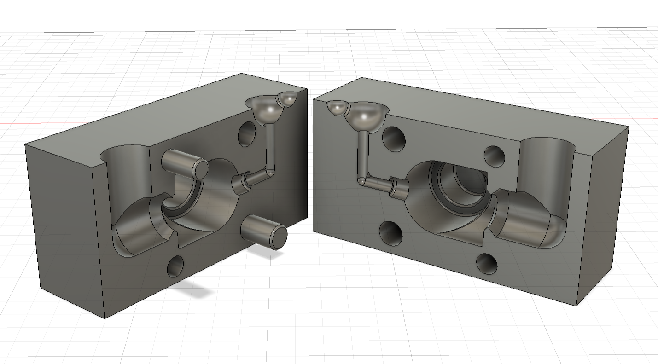

Figure 1.7 View of the half-shells

Pag. 11 | 68
With regard to the use of cores, we opted for a steel core. The decision to employ a core was made to create an internal cavity that would have been difficult to obtain using a traditional casting process. Although the use of a core incurs a production cost, it can be reused, thereby reducing material waste that would otherwise result from a subsequent internal drilling operation on the mechanical component — an operation that would also entail significant costs. Moreover, the core contributes to the reduction of defects such as porosity and voids in areas farther from the pouring point, thereby improving the final quality of the part. Although the initial plan was to insert two cores, including one for the shorter cylinder, this idea was later abandoned, as the manufacturing and positioning of the second core would have presented both draft and economic challenges. The diameter of the cylinder (Φ 24 mm) was selected based on the tapping pre-hole required for the ¾" gas thread, namely Φ 25.40 mm.
CORE

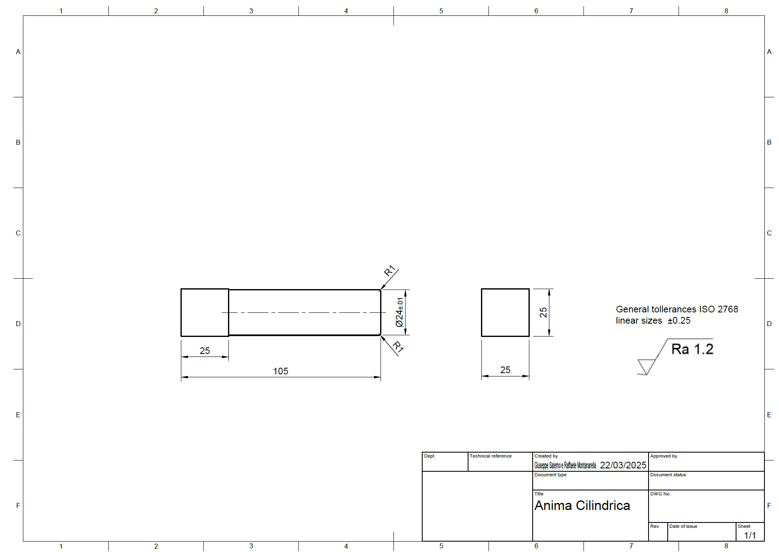
Technical drawing of the core with its respective measurements, roughness, and tolerances

Pag. 11 | 68
Disegno tecnico anima con relative misure rugosità e tolleranze
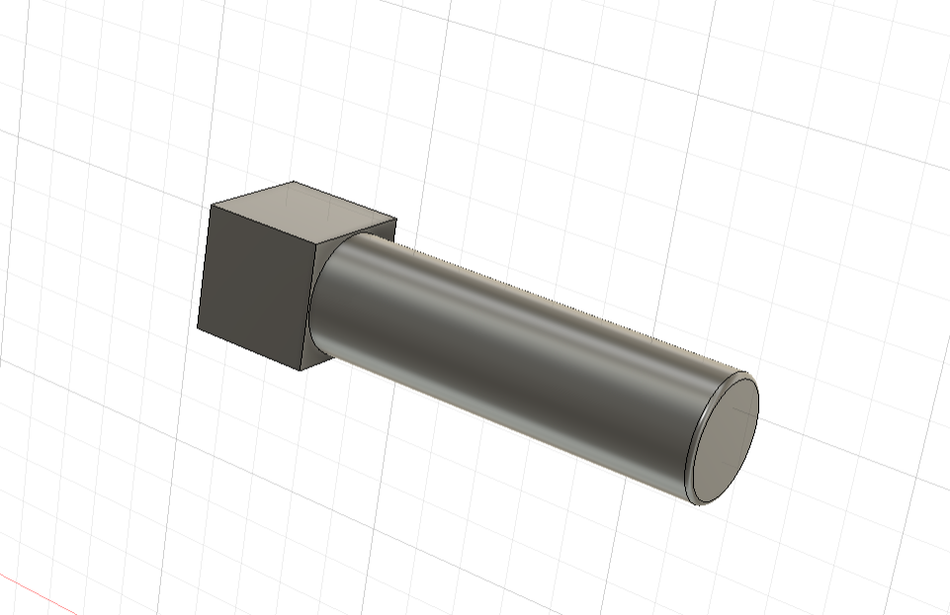
3D Representation Format of the Core

COOLING MODULI

n order to predict the solidification behavior of the raw casting with a reasonably low margin of error, the study of the cooling modulus is essential. Thanks to Chvorinov's studies, it is possible to approximate the solidification time of the casting using the following formula:
$$t=\frac{1}{k^{2}}M^{2}$$
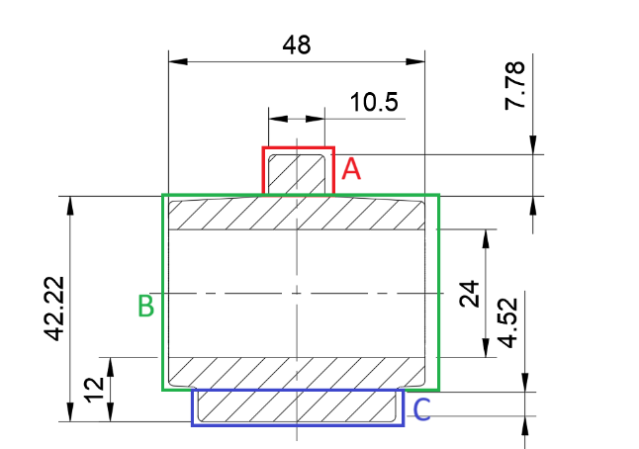
where M denotes the cooling modulus and k is a material-specific constant for the casting metal (for brass, k = 0.07, as it is a copper-based alloy, as indicated in “Santochi”). This formula shows that the solidification time is proportional to the square of the cooling modulus; therefore, we will analyze the latter to study the solidification direction of the raw casting.
To calculate the cooling modulus of our raw casting, we can, with a reasonable degree of approximation, divide it into three cylinders, two of which are solid (A and C) and one hollow (B) (Figure 1.8).
The cooling moduli can be calculated by dividing the volume of the cylinders by their heat exchange surface area, according to the following formula:
Pag. 12 | 68
Figure 1.8
$$M=\frac{V}{S}$$
which, in our case, can be obtained using the formulas shown in Figure 1.9, relationships demonstrated by Chvorinov starting from the case of plates (after all, toroidal bodies can be considered as bars bent along a
certain radius of curvature).

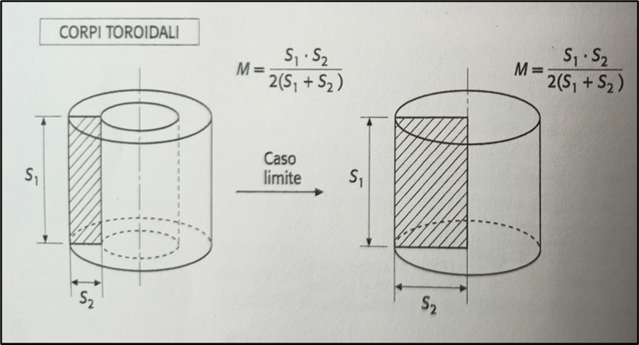

Figure 1.9 Approximate Methods for Calculating the Cooling Modulus of Simple Solid Shapes

The data obtained are summarized in the following table:
Pag. 13 | 68
Cylinder | Values (in mm) | Volumes (in ${mm}^{3}$) | Moduli $M_{i}$ (in $mm$)
A | $$s_{A1}=7.78$$  $$s_{A2}=5.25$$ | $$V_{A}=673.67135$$ | $$M_{A}=1.5673$$
B | $$s_{B1}=48$$  $$s_{B2}=6.5$$ | $$V_{B}=29895.396$$ | $$M_{B}=2.8624$$
C | $$s_{C1}=6.5$$  $$s_{C2}=18.5$$ | $$V_{C}=6988.86556$$ | $$M_{C}=2.405$$

Nota: $s_{B2}≡s_{C2}=\frac{\left(37-24\right)}{2}=6.5$
The highest cooling moduli obtained are those of cylinders B and C: we chose to connect the riser to cylinder C for three technical reasons:

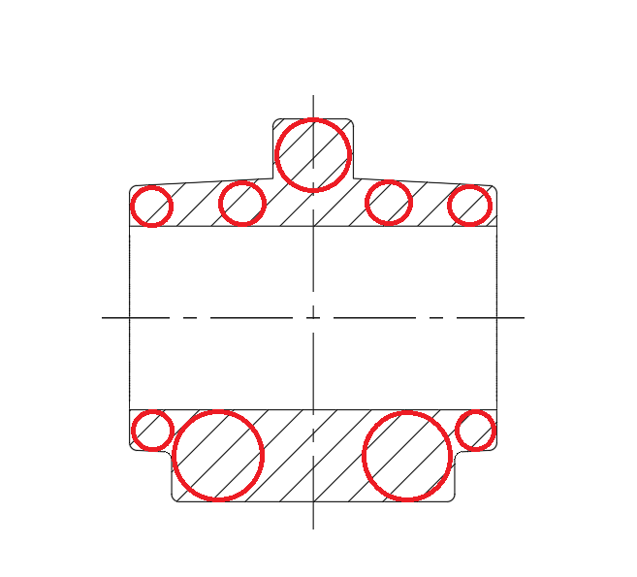
1 The cooling moduli M_B and M_C have very similar values; therefore, connecting the riser to either one does not significantly affect the solidification direction.
Figure 1.10 Heuvers' Circle Method

2 → Using the Heuvers circles method (Figure 1.10), it can be deduced that solidification will be slower in cylinder C, as it is possible to inscribe circles within it with a larger radius compared to those that can be inscribed within the hollow cylinder B.

3 → Since the parting plane is orthogonal to the axis of cylinder B, the only ways to place the riser relative to it would have been either positioning it above, significantly altering the geometry of the part, or to one of the sides, which would result in the formation of an undercut (during the extraction of the raw casting, the riser would remain stuck in the mold).
RISER

The riser is a crucial component to prevent the raw casting from having porosity: it will, in fact, be the part of the raw casting in which the shrinkage cone will form, and, once cut off, it will not cause structural or functional defects to the body of the valve. It must have a cooling modulus given by the following formula:

$$M_{m}=1.2∙M_{B}=3.43488 mm$$

This value is determined by the product of two factors: one is the largest cooling modulus obtained in the previous section, and the second is related to the fact that during solidification, the riser will have a
Pag. 14 | 68
decrease in its cooling modulus of approximately 17% of the original value due to the formation of the shrinkage cone.
Having decided to create a cylindrical riser (for ease of mold release and manufacturing, which implies a lower cost), the maximum volume of the riser is obtained from the theoretical study of the shrinkage cone using the following formula:
$$V_{max}=V_{m}∙(\frac{14}{b}-1)$$

with $b=6.7\% (Volumetric shrinkage coefficient percentage of brass)$

$V_{m}=179∙{\left(M_{m}\right)}^{3}=7254.170164 {mm}^{3}$ (vedi figura 1.11)
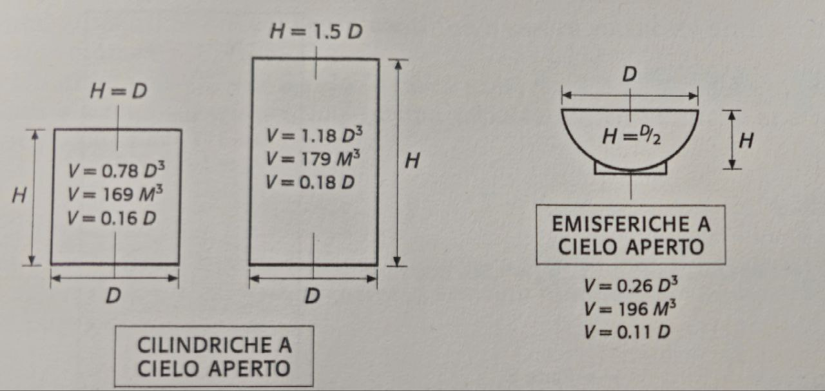

Figure 1.11 Main Relationships Linking the Volume V of Risers, the Cooling Modulus M, and the Characteristic Dimensions (Source: Santochi)

From which we obtain $V_{max}=7903.797343 {mm}^{3}$

If we compare this value with the (approximated) volume of cylinder B, that is, the section of the raw casting that needs to be protected by the riser, we find that the riser is not yet properly sized. In fact, we obtain:
$V_{B}=π∙h∙\left(r_{B}^{2}-r_{B}^{'2}\right)=π∙48mm∙\left({\left(\frac{37}{2}mm\right)}^{2}-{\left(\frac{24}{2}mm\right)}^{2}\right)=29895.39569 {mm}^{3}$
da cui $\frac{V_{B}}{V_{m}}=4.1211324$, cioe $V_{B}≫V_{m}$
Pag. 15 | 68
This sizing error is also confirmed by the Caine diagram shown in Figure 1.12, where our raw casting is identified by the coordinates x = M_m / M_B and y = V_m / V_B, represented at the point "Defective Raw Casting". The equation of the Caine curve is
$$y=\frac{a}{x-c}+b$$
where a = 0.1, b = 0.067 (volumetric shrinkage coefficient of brass), and c = 1 (since the riser is not insulated).
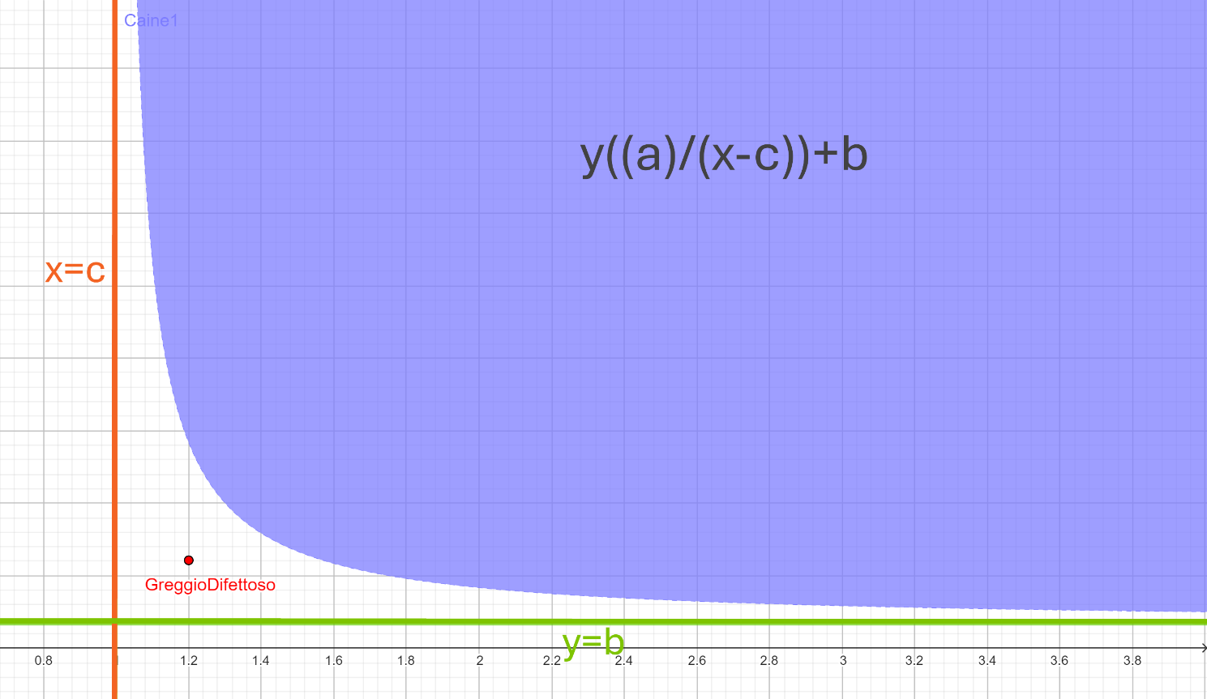

Figure 1.12 Caine Diagram for Defective Casting

To solve this problem, we found, using the relationships from Figure 1.11, the diameter corresponding to the riser of volume V_m and incremented it by unit quantities until we reached a value where the raw casting fell within the zone of healthy parts.

$$D_{1}=\sqrt[3]{\frac{V_{m}}{1.18}}=\sqrt[3]{\frac{7254.170164 {mm}^{3}}{1.18}}=18.3190mm$$
We arrived at the value D' = 24 mm, with which we obtain $V_{m}^{'}=1.18{D^{'}}^{3}=16312.32mm^{3}=> M_{m}^{'}=\sqrt[3]{\frac{V_{m}^{'}}{179}}=4.5$
Pag. 16 | 68
Verifichiamo ora dove ci troviamo nel diagramma di Caine nella figura 1.13
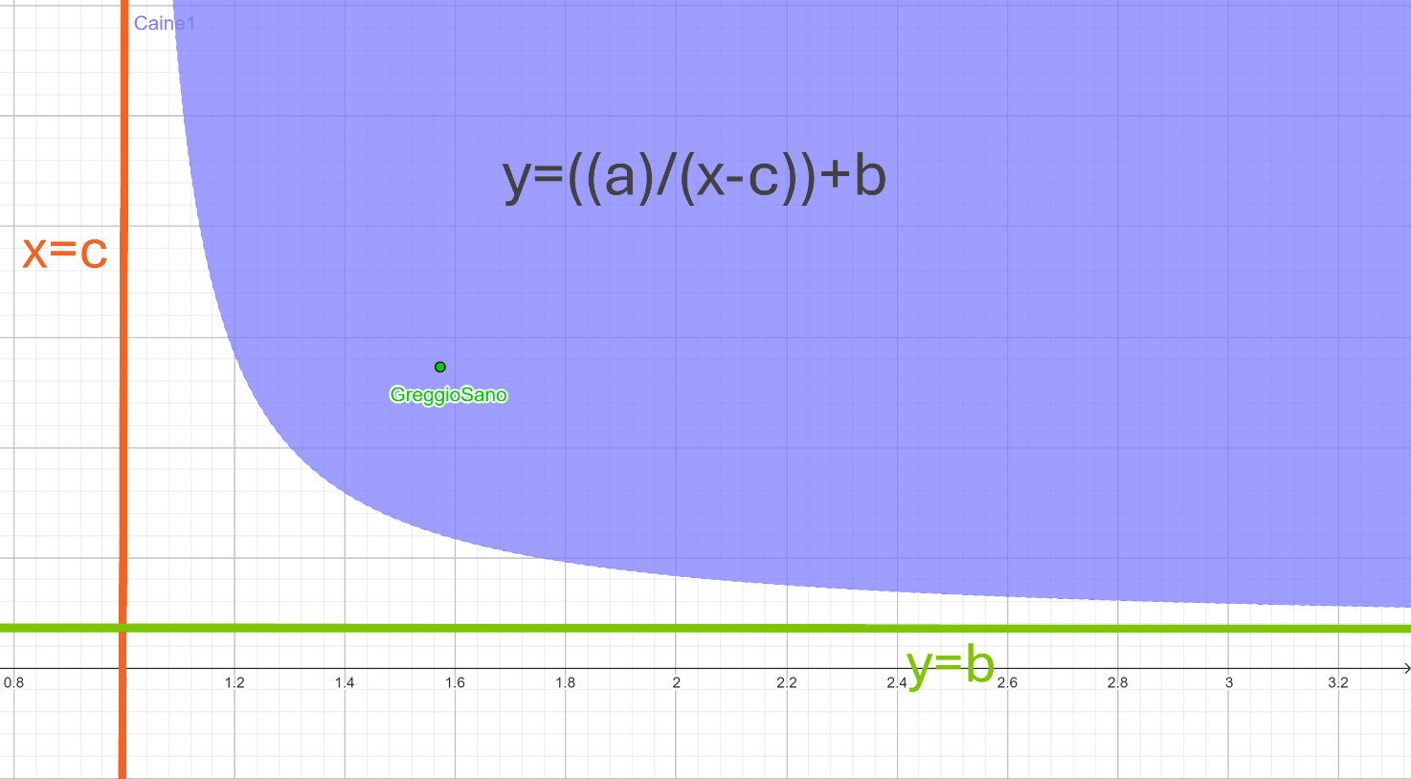

Figure 1.13 Caine Diagram with Sound Casting

As can be seen, the riser is now properly sized: according to the formulas in Figure 1.11, it will have the following dimensions:

$$D_{m}=D^{'}=24mm{, H}_{m}=1.5⋅D_{m}=36mm$$

Now, we dimension the attachment collar according to the formulas in Figure 1.13.
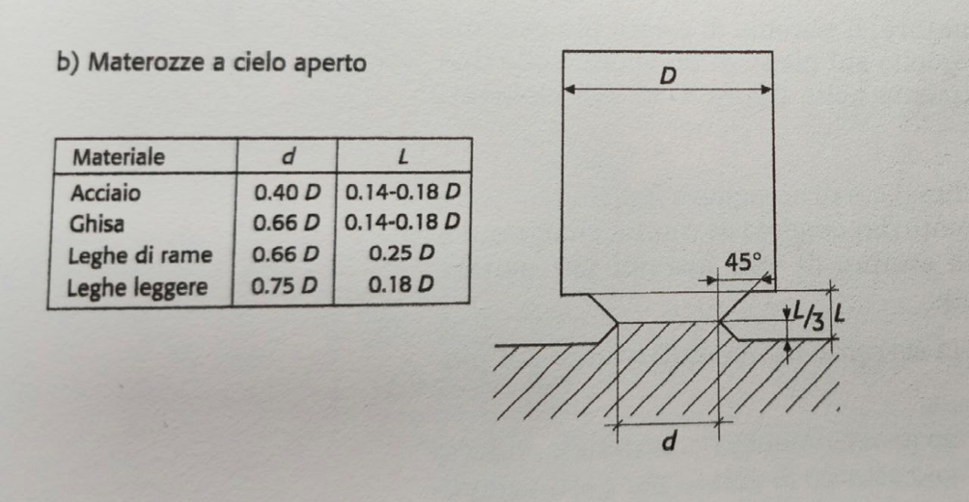

Pag. 17 | 68
We then obtain:

$$d=0.66∙D_{m}=0.66∙24mm=15.84mm≅16mm,$$
$$L=0.25∙D_{m}=0.25∙24mm=6mm$$
POURING CHANNEL

To dimension the gate channel, we must consider the maximum height reached by the riser: since we placed the riser at the center of cylinder C, the height of the gate channel must be equal to that of the riser.
$$H_{m}=h_{c}=36mm$$
We can also calculate the cross-section of the gate channel by considering the pouring time T using the following formula:
$$T=3.2∙\sqrt{G}$$
where G is the weight of the casting [kg], which is obtained from the formula G = V ∙ ρ, with V being the volume of the casting (we approximate V = V_A + V_B + V_C + V_m' = 53870.25291 mm³ ≅ 0.0539 L) and ρ being the density of the casting material (in our case, ρ = 8.73 kg/L), from which we obtain
$$T=3.2∙\sqrt{V∙ρ}=3.2∙\sqrt{0.0539L∙8.73\frac{kg}{L}}=2.1951s$$

Considering v = √(2 ⋅ g ⋅ h_c), with g = 9.81 m/s² (acceleration due to gravity), the approximate velocity (without head losses) of the fluid stream at the exit of the gate channel, and defining K = G/T as the total weight flow rate of the gate connection, we find the cross-section of the gate connection S_c from the formula:
Pag. 18 | 68
$$S_{c}=\frac{K}{v⋅ρ}=>S_{c}=\frac{G}{T⋅\sqrt{2⋅g⋅h_{c}}⋅ρ}=\frac{V∙ρ}{T⋅\sqrt{2⋅g⋅h_{c}}⋅ρ}=\frac{53870.25291{mm}^{3}}{2.1951s⋅\sqrt{2⋅9810\frac{mm}{s^{2}}⋅36mm}}=>S_{c}=29.2 {mm}^{2}$$
Since we will create a cylindrical gate channel, from this value we can derive the diameter d_c using the inverse formula for the area of a circle, obtaining:
$$ⅆ_{c}=2\sqrt{\frac{S_{c}}{π}}=6.0974 mm≈6 mm$$
RAIN POURING SYSTEM

We have decided to use a rain casting system, as this process allows for uniform filling of the mold, even in the most difficult-to-reach areas. Top-down pouring allows the metal to flow evenly, significantly reducing the risk of porosity and casting defects. Given that it is intended for the production of a high quantity of parts, rain casting is particularly advantageous, as it reduces the need for additional operations to correct any surface imperfections or shape defects, thereby improving overall production efficiency. Moreover, rain casting helps to minimize cycle times, increasing productivity without compromising dimensional accuracy, a crucial aspect for a valve intended for high-pressure operations. The problem with this casting system is related to the potential formation of cold drops, which can cause defects in the finished part. This phenomenon occurs during pouring due to a temperature drop of the metal as it descends into the mold. However, this issue can be easily resolved by using heaters to maintain the temperature of the molten metal consistently throughout the pouring process. It is essential that the pouring process is carefully controlled to prevent further formation of cold drops and ensure uniform mold filling.

Pag. 19 | 68
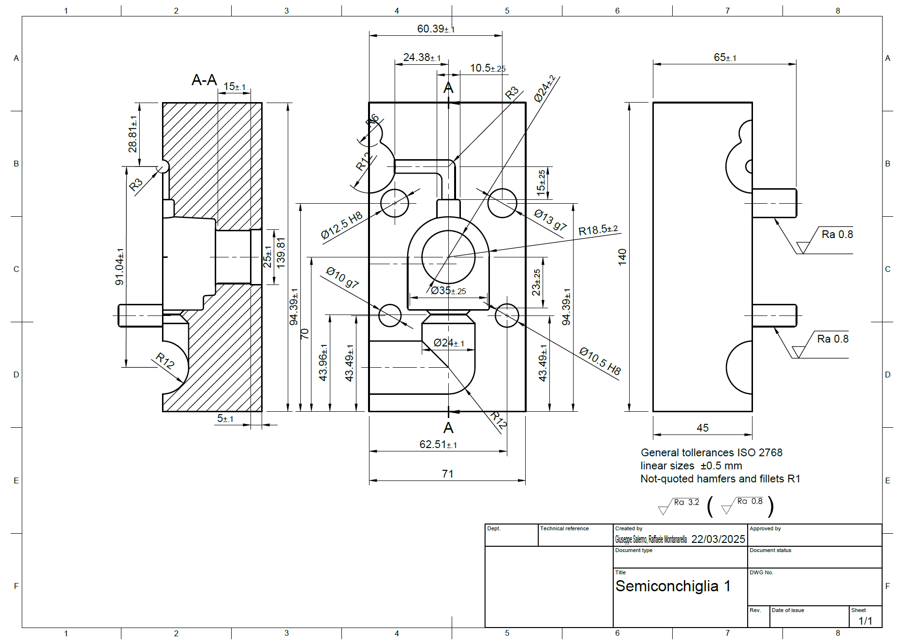
TECHNICAL DRAWING OF THE MOLD

.

Figure 1.14 Perforated Half-shell 1 with Centering Pins, Including Roughness and Tolerance Measurements

As can be seen in Figures 1.14 and 1.15, the half-shells have four holes. From half-shell 1 (Figure 1.14), two cylinders protrude, which will serve as a locking and centering system between the two shells. Once assembled, it will be necessary to add two screws: one M10 screw and one M12 screw, which will be used to secure the shells and prevent the molten material from leaking out.

Pag. 20 | 68
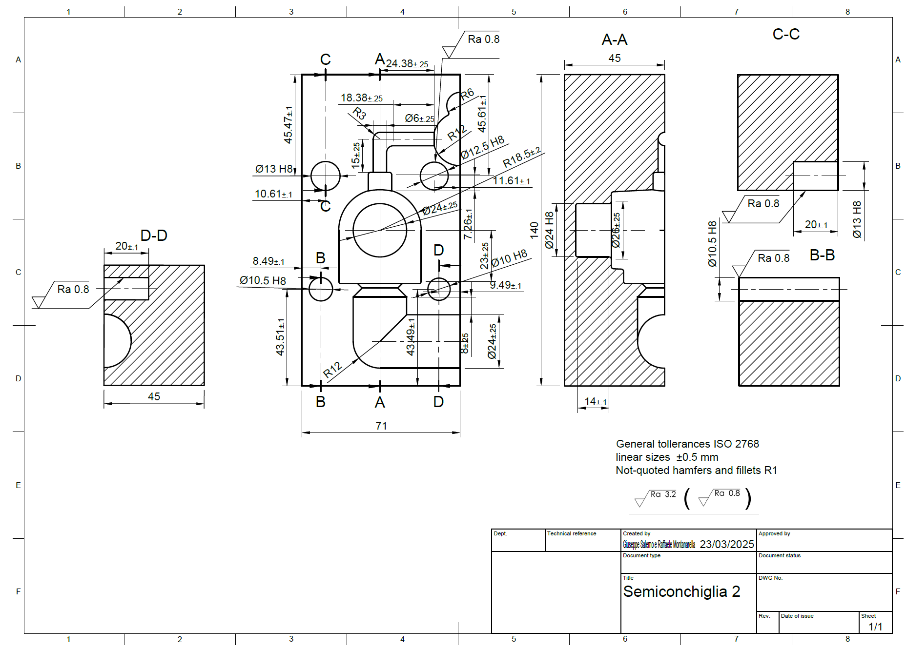

Figure 1.15 Perforated Half-shell 2 with Centering Pins, Including Roughness and Tolerance Measurements

Pag. 21 | 68
INSPIRE CAST
Below are the images showing the simulation of the molten material filling the mold, directly from the gate channel.
The program used for this filling analysis, as indicated by the title, is "Inspire Cast".
An advanced simulation software for the design and optimization of casting processes, developed by Altair, a company offering software solutions for engineering and design. Inspire Cast is particularly useful in the foundry industry, as it allows for the simulation of the metal casting process and the prediction of potential defects before the part is physically produced.

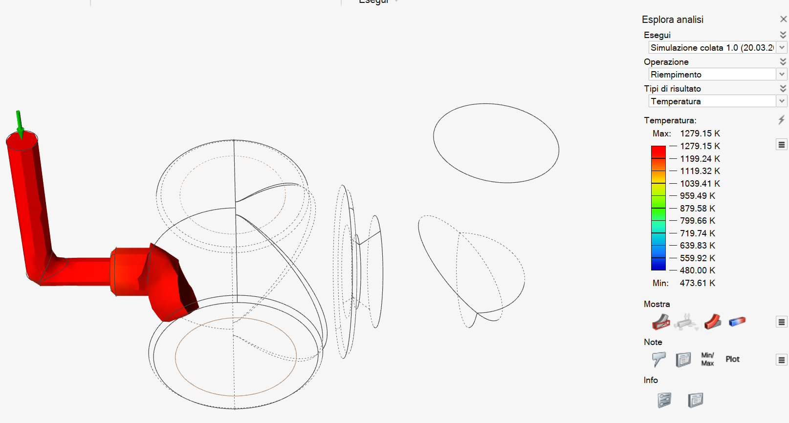

Filling n.1

Pag. 22 | 68
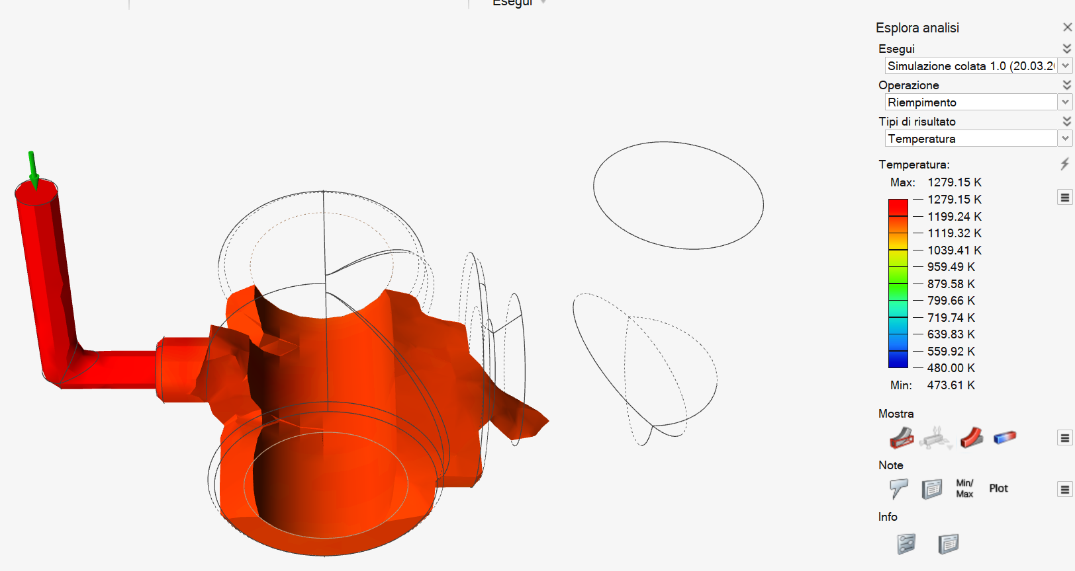
Pag. 5 | 68

Filling n.2

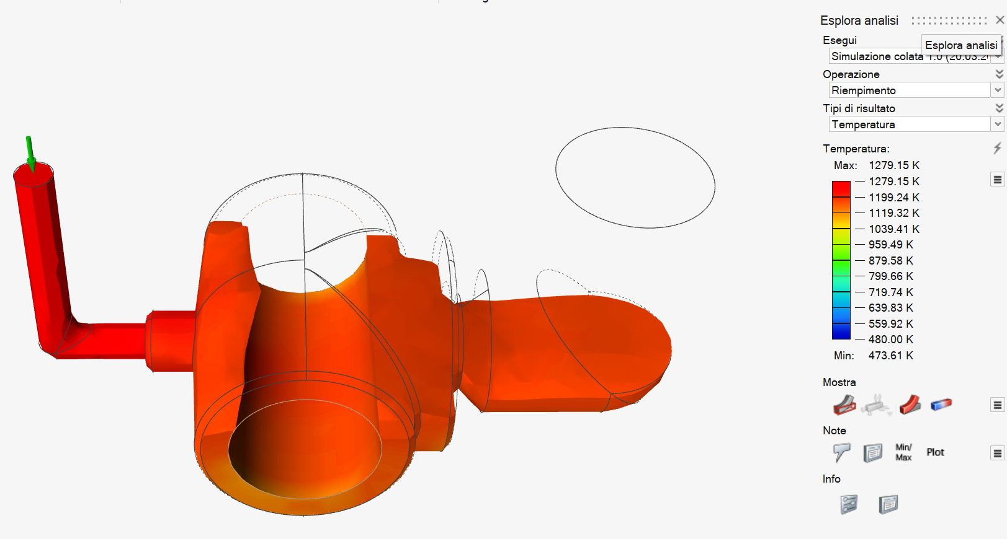

Filling n.3

Pag. 23 | 68
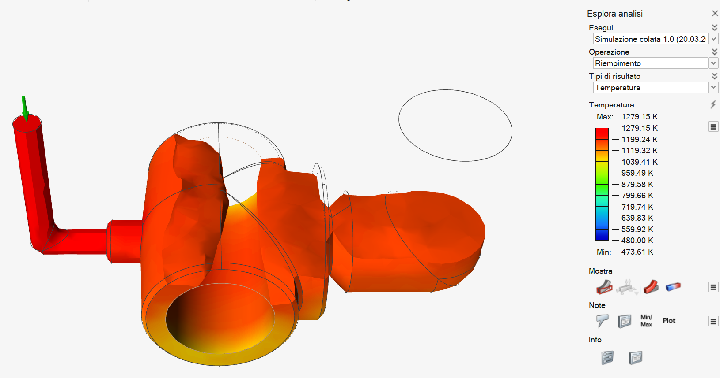
Pag. 5 | 68

Filling n.4

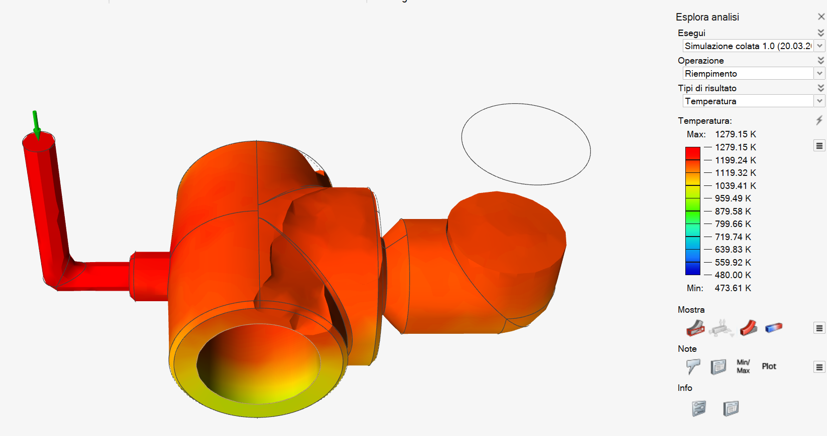

Filling n.5

Pag. 24 | 68
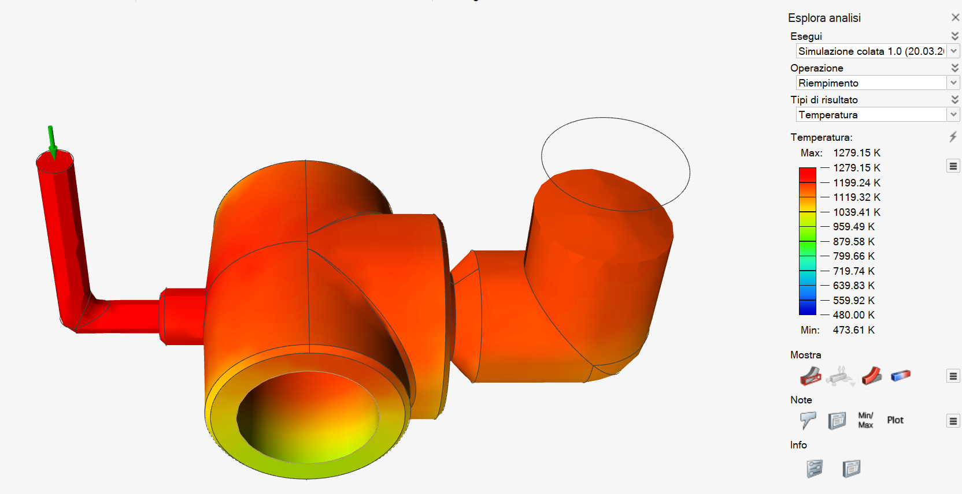

Filling n.6

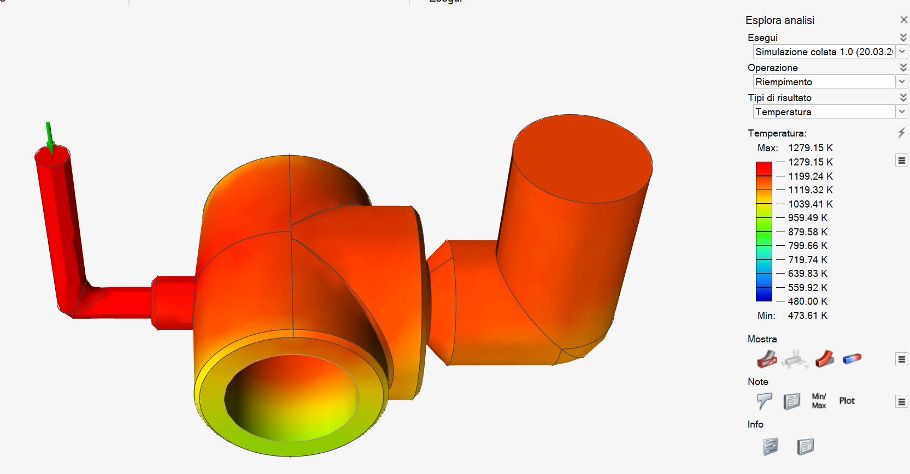

Filling n.7

Pag. 25 | 68
SOLIDIFICATION TIME

Below are the images showing the simulation of the molten material filling the mold, directly from the gate channel.
The program used for this filling analysis, as indicated by the title, is "Inspire Cast".
An advanced simulation software for the design and optimization of casting processes, developed by Altair, a company offering software solutions for engineering and design. Inspire Cast is particularly useful in the foundry industry, as it allows for the simulation of the metal casting process and the prediction of potential defects before the part is physically produced.

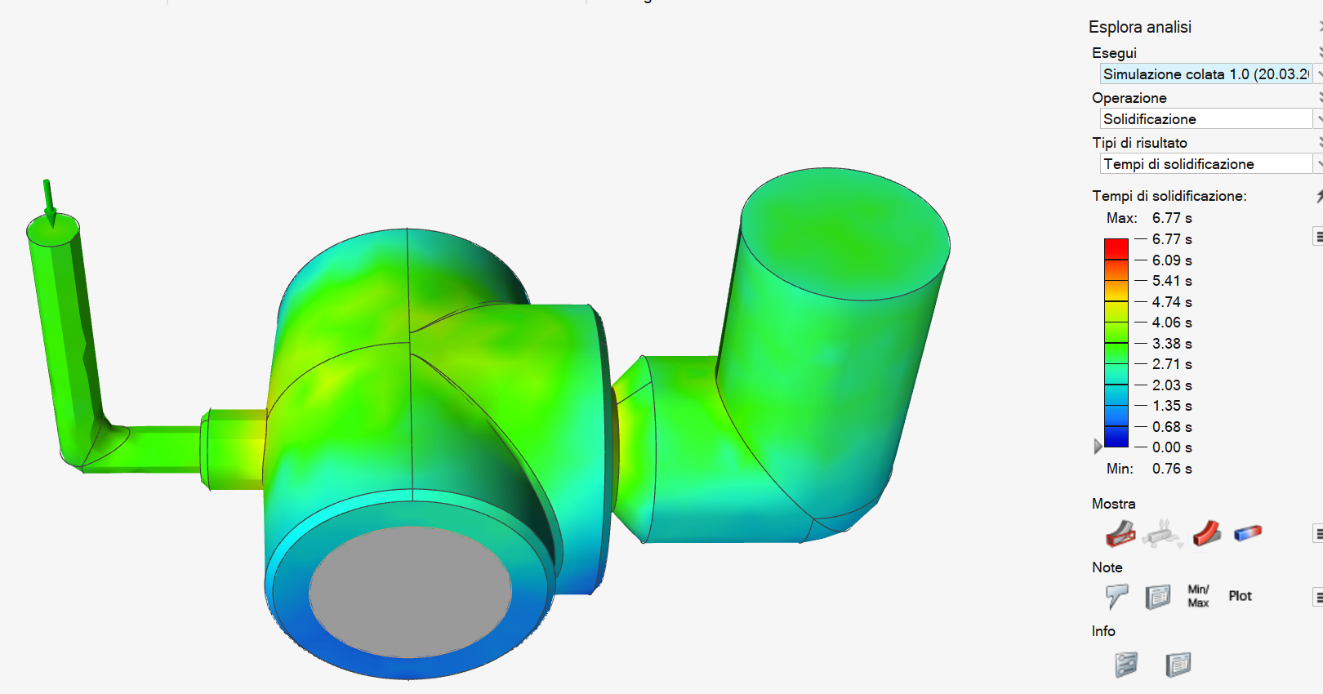

Figure 1.16 Representative Image of Solidification Times

Pag. 26 | 68
Among its features, Inspire Cast allows for the verification of porosity and entrapped air within the mechanical part. Inspire Cast simulates the solidification of the metal during casting, detecting the formation of porosity caused by air voids or trapped gases.
When the metal is poured into the casting mold, air bubbles may become trapped, causing voids within the part. The software also simulates this phenomenon, predicting air accumulation and providing a detailed map of the expected porosity within the part, identifying the most critical areas.
POROSITY AND TRAPPED AIR

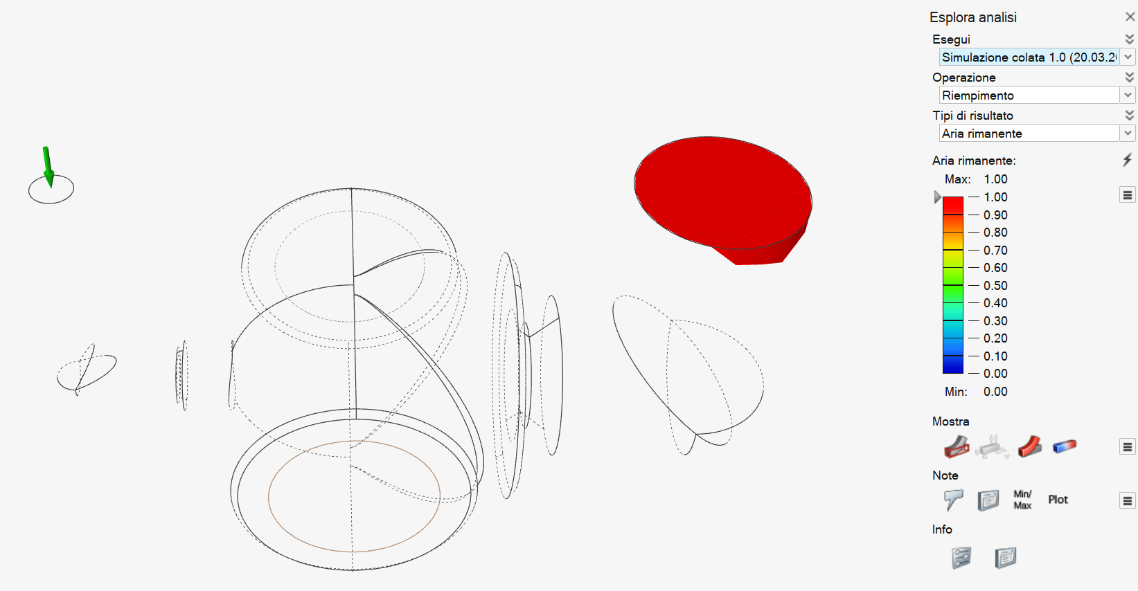

Figure 1.17 Remaining Air Inside the Mechanical Part

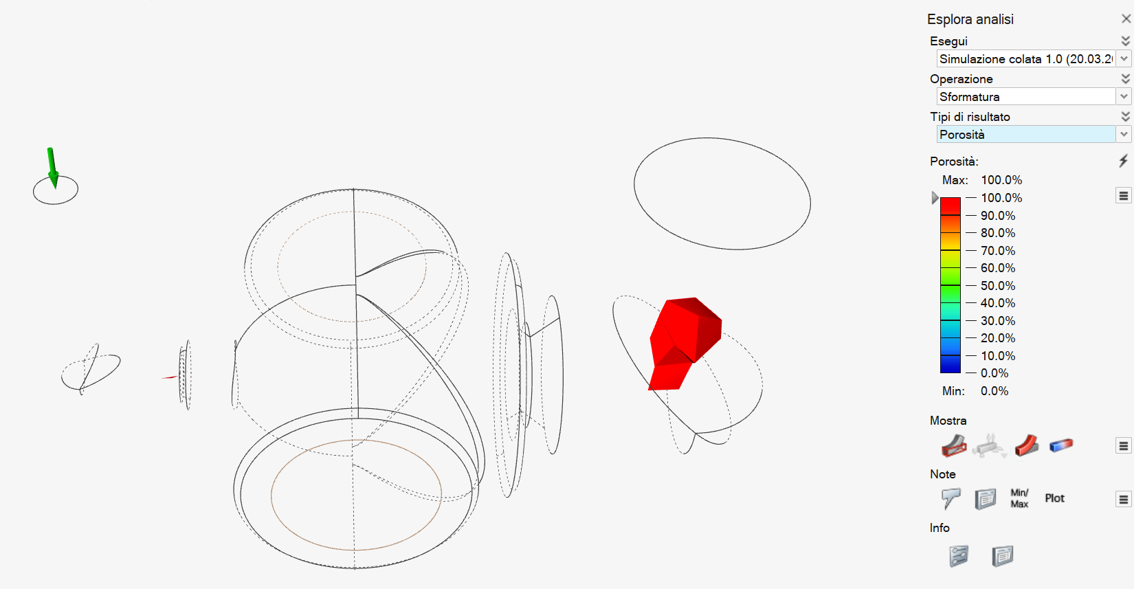

Pag. 27| 68
Figure 1.18 Porosity of the Mechanical Part
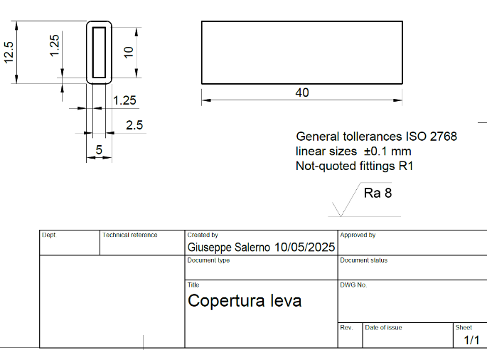
Lever cover

3D PRINTING

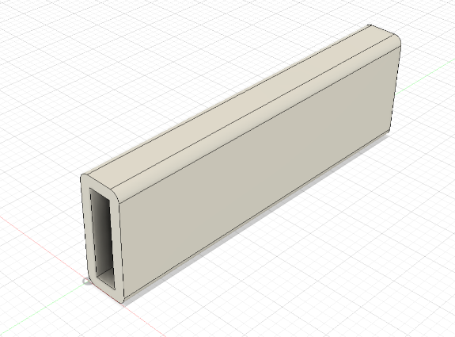

As for 3D printing, we have decided to adopt this process for the production of the actuator valve lever cover. Since this component may be used in both industrial and civil settings, the cover will make its operation easier.
We have chosen to use the FDM (Fused Deposition Modeling) process, one of the most widespread and accessible technologies in the world of 3D printing, which was also demonstrated during class. The following tables list the main characteristics and advantages of this process compared to other methods.

Aspect
  Advantages of FDM Compared to Others
Initial cost
  Much lower than SLA, SLS, or DMLS
Ease of use | Perfect for beginners, students, and hobbyists
Low-cost material
  Filaments are widely available and inexpensive
Maintenance
  Simpler and less expensive
Safety
  No use of toxic resins or hazardous powders
Prototyping speed
  Ideal for fast and iterative testing
Flexibility | Wide range of materials and customization options
Table 1 – Advantages of the FDM Method
Pag. 28 | 68
- Lower resolution compared to SLA (stereolithography) or DLP, which offer smoother surface finishes;
As for the disadvantages, we have:

- Anisotropic mechanical strength;
- Support structures are more difficult to remove, especially on complex geometries.

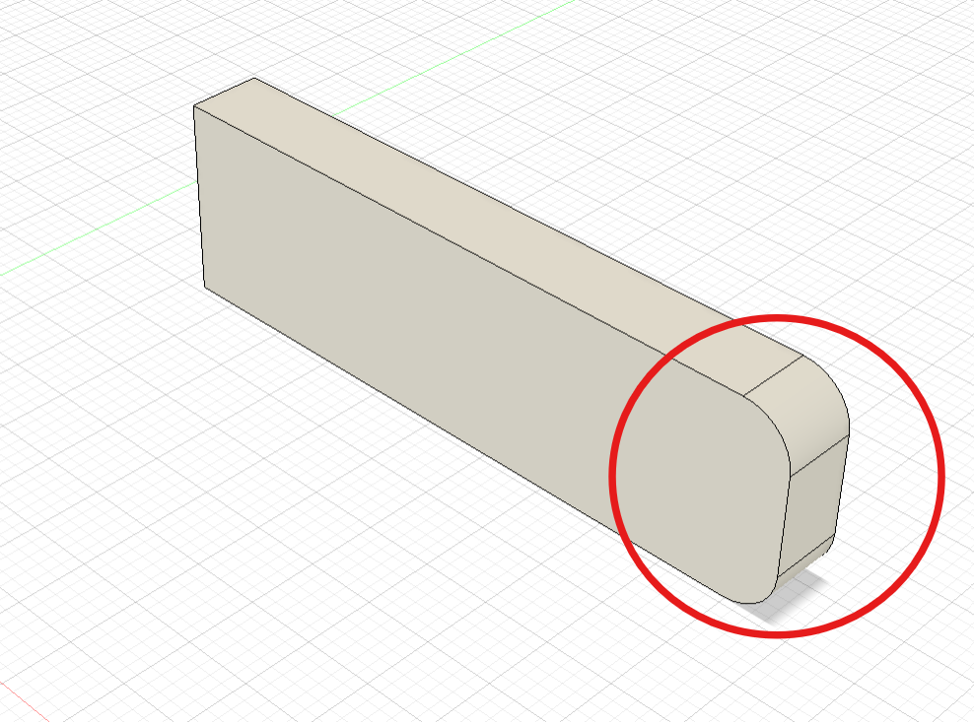
In our case, these disadvantages do not compromise the functionality of the part in any way. In fact, since it is a lever cover, surface quality and mechanical strength are not critical, and the geometry is relatively simple.
Regarding the geometry, we initially opted for a different shape of the cover, one that would entirely follow the metal sheet lever (see Figure 2.0). However, this design would have compromised the process, as the detailed fabrication of the final part (circled in red) would have been difficult, especially for producing two fillets of that kind. Since it is simply a cover, this design change does not affect its intended function.
Figure 2.0 – Original Design Idea Modified During the Design Phase

Material:

As for the material, we chose thermoplastic polyurethane (TPU), which combines the properties of rubber and plastic in a soft, flexible material. It features strong interlayer bonding, which improves its resistance to chemicals: industrial oils and chemical products have little effect on it due to its good corrosion resistance.
Below is the material's technical datasheet.

Pag. 29 | 68
Table 2 – Mechanical and Physical Properties of TPU
TPU Property | Value
Tensile modulus | 26 MPa
Tensile strength | 8.6 MPa
Elongation at break | 580%
Hardness (Shore A) | 95
Melting temperature (20°C/min) | 220°C
Heat deflection temperature (1.80 MPa) | 49°C
Heat deflection temperature (0.45 MPa) | 74°C
Density | 1.22 g/cm³
How does the process take place

The production of the part begins with creating a three-dimensional model, designed using CAD software (in our case, Fusion). Once completed, the model is exported in a format compatible with the printer, usually STL or 3MF.
At this point, slicing software comes into play, which divides the model into a series of horizontal layers and generates a G-code file containing all the instructions needed for the 3D printer, such as nozzle paths (toolpath), temperatures, and speeds.
Once the file is ready, the material is loaded. In FDM printing, a thermoplastic filament wound on a spool is used. The filament is fed into the extruder, which guides it to the hooted the part of the printer that can reach temperatures between 180°C and 260°C depending on the material used (in our case, 225°C).
When the filament reaches the hot nozzle, it melts and is extruded through a small opening, depositing layer by layer onto the print bed. This process is repeated until the object is fully formed. The bed can be heated to ensure better adhesion of the first layer and reduce the risk of warping. To ensure good print quality, many FDM printers have fans that promote rapid cooling of the freshly deposited material.
Pag. 30 | 68
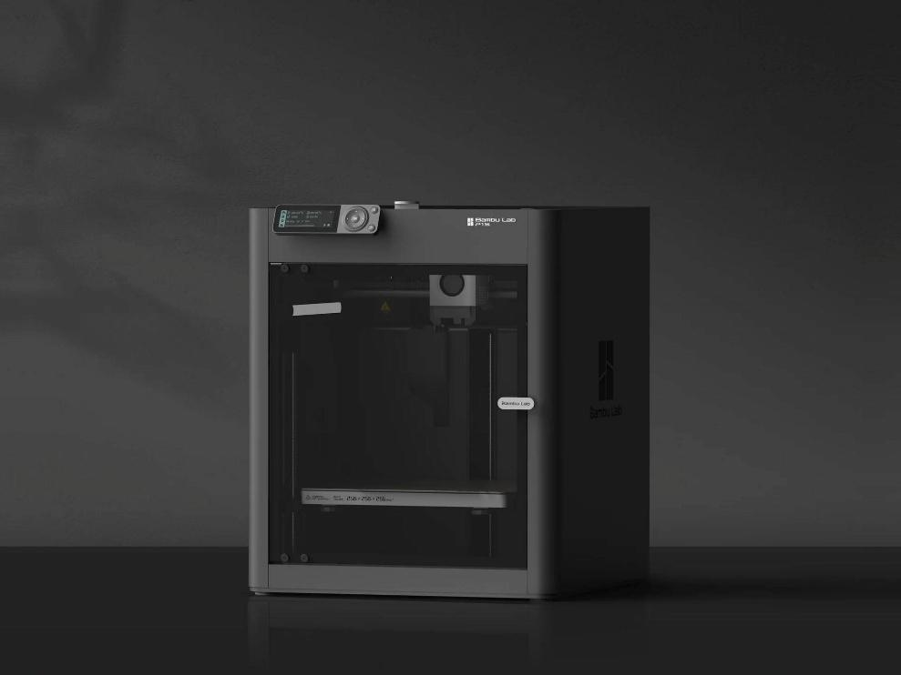
After printing is complete, the object is allowed to cool and then removed from the bed. Post-processing operations are often necessary, such as removing supports, sanding the surface, or thermal treatments to improve appearance or mechanical properties.
We decided to use the Bambu Lab P1S 3D printer (Figure 2.1) for the reasons listed below.

Figure 2.1 – Bambu Lab P1S Printer

Table 3 – Bambu Lab P1S Printer
Feature | Advantage for Production
High speed (250+ mm/s) | Faster printing cycles
High reliability | Few errors in large batches
Auto-calibration | No downtime between prints
Filament/vibration sensors | Waste and machine downtime avoided
Excellent out-of-the-box quality | Minimal tweaking required
Multimaterial support (AMS) | Useful for diversifying parts in the future

Pag. 31 | 68
Printing parameters:

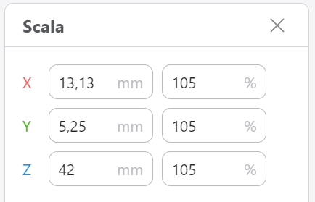
After exporting the CAD model in “.stl” format, we imported it into Snapmaker Luban, a free application demonstrated in class that allows management of 3D printing parameters for the process.
First, we increased the size of the part to compensate for TPU shrinkage (Figure 2.4).
Figure 2.4 – Part Dimensions
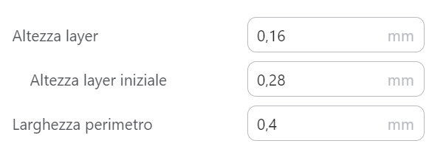
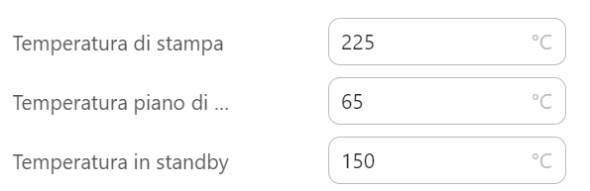
Next, we selected the layer height for material deposition, which is smaller than the nozzle diameter (AA 0.40) (see Figure 2.2), as well as the working temperatures for the build plate and the nozzle (see Figure 2.3).
Figure 2.2 – Layer Dimensions
Figure 2.3 – Operating Temperatures

Finally, we chose the orientation of the cover: as evident from the following images (Figures 8 and 9), placing the part horizontally would have occupied more space on the build plate, taken more time, and required internal supports to prevent collapse during printing. All these disadvantages are overcome by positioning the cover vertically. This clearly shows how the design modification categorically optimized the processing times and costs (see “Processing Costs and Times”).

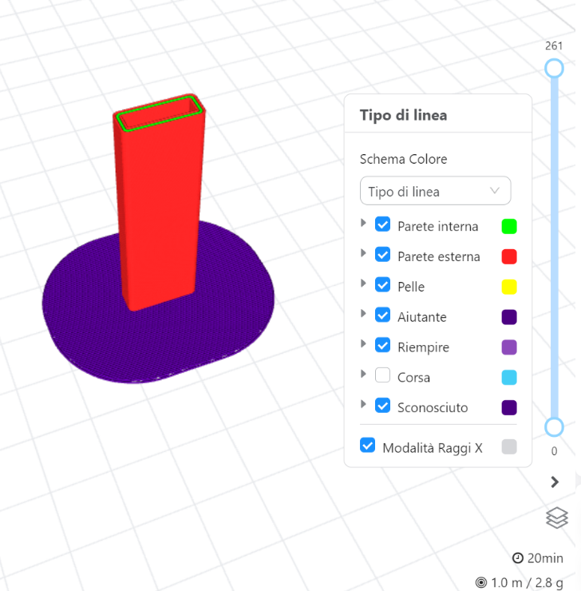
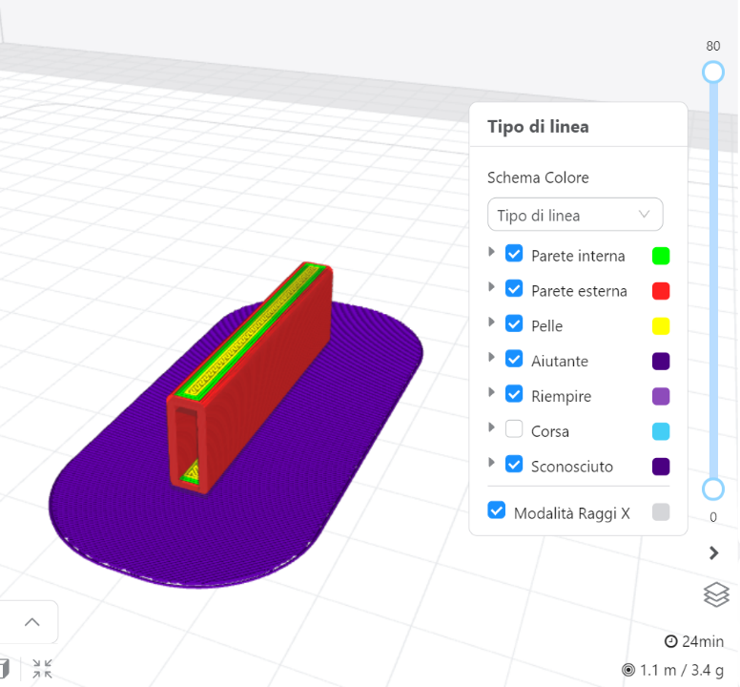

Pag. 32 | 68
CHIP REMOVAL
Regarding chip removal, several components of the valve require this set of operations to be manufactured. These components are:
- the valve body;
- the operating shaft;
- the adjustment ring.
We will analyze the drawings of each component one by one to determine which operations to perform in order to produce the finished part: this serves as the input for compiling the process sheet.
CORPO DELLA VALVOLA

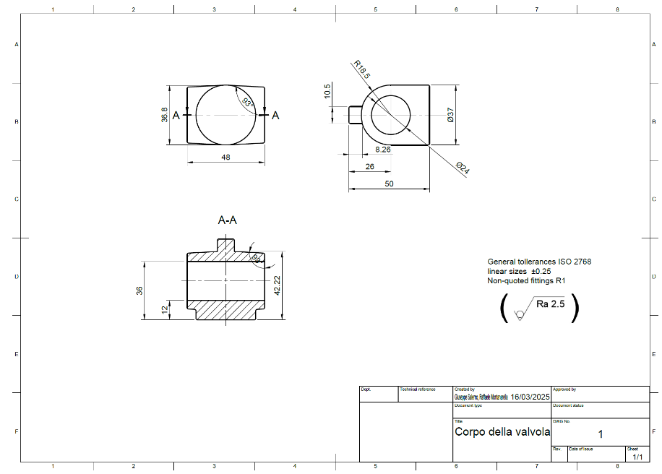
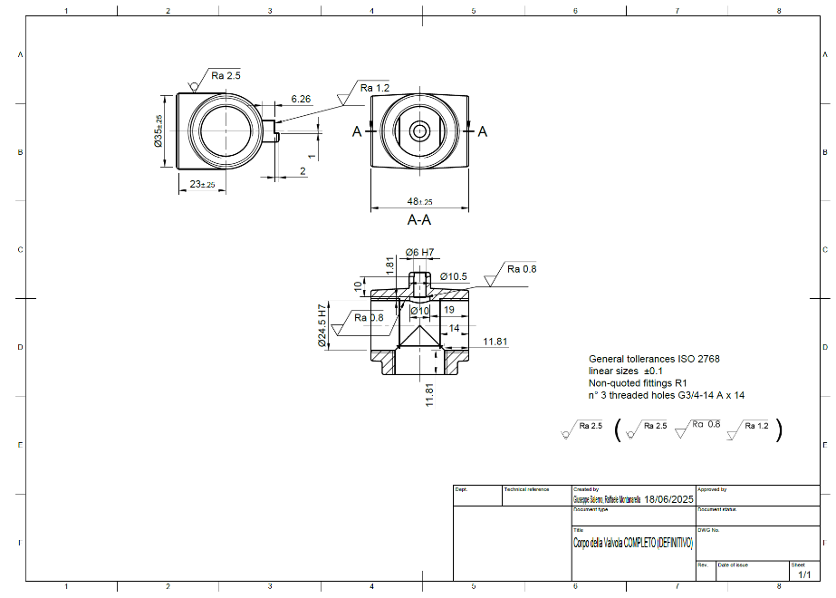
Figure 3.2 – Finished Valve Body

Figure 3.1 – Valve Body Obtained by Casting

After removing the pouring channel and the riser by sawing, we obtain a raw casting that must first be drilled perpendicularly to the existing hole (created by the core during the casting process). It is also noted that the holes have an H7 tolerance and a surface roughness of Ra 0.8—surface qualities important for the sliding and rotation of the operating shaft (∅ 6 hole) and the housing of the ball (∅ 24.50 hole). The larger diameter holes also need to be tapped. Inside the valve body, there is a groove where the operating shaft will fit. Finally, there is a shoulder on the smaller cylinder, which allows the actuator lever to rotate only 180°.
Pag. 33 | 68
From this qualitative analysis, we can establish the necessary processes and machine tools required to manufacture the valve body, which are:
- Column drill;
- Universal milling machine;
- Engine lathe;
MACHINE:

Pag. 34 | 68
Column Drill | HBM Professional Floor Model, 32 mm Capacity | 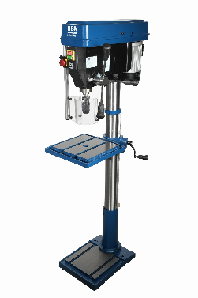
Dimensions & Weight | Total height | 1700 mm
 | Worktable size | 350 mm × 350 mm
 | Base dimensions | 350 mm × 460 mm
 | Packaging dimensions | 1420 mm × 660 mm × 330 mm
 | Net weight: 95 kg | 95 kg
Structure | Column diameter | 92 mm
 | Max distance spindle to machine base | 1100 mm
 | Max distance spindle to table | 650 mm
 | Overhang (distance column to spindle axis) | 220 mm
Spindle & Movement | Spindle support | MC4
 | Spindle travel | 120 mm
 | Max drilling capacity in steel | 32 mm
Transmission | Motor power | 1100 W
 | No-load speed | 2450 rpm
Power Supply | Voltage | 230 V
Price | €749.99
Milling Machine | HBM BF 45 Profi with 3-Axis LCD Digital Readout System | 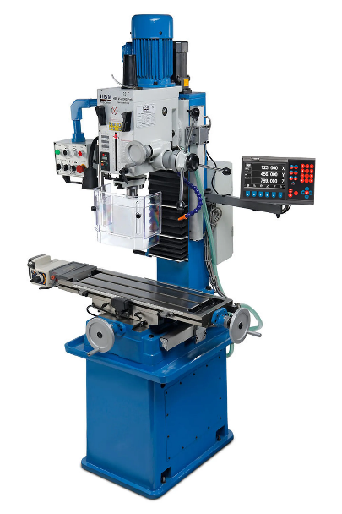
Dimensions & Weight | Width | 96 cm
 | Height | 210 cm
 | Length | 118 cm
 | Product dimensions | 118 cm x 96 cm x 210 cm
 | Footprint | 118 cm x 96 cm x 210 cm
 | Packaging dimensions | 118 cm x 96 cm x 210 cm
 | Net/product weight | 580 kg
Structure & Table | Table | 240 mm x 800 mm
 | With powered table feed | Yes
 | With readout box | Yes
 | With cooling system | Yes
 | Column structure | Yes
 | Dovetail guides | Yes
Connections | Spindle connection | ISO30
Spindle & Movement | Spindle travel | 125 mm
 | Max spindle-table distance | 460 mm
 | Max longitudinal travel (X) | 560 mm
 | Max lateral travel (Y) | 230 mm
 | Tilting head | ±90° (left/right)
 | Micrometric head adjustment | Yes
Machining / Capacity | Max drilling capacity in steel | 45 mm
 | Max milling capacity in steel | 32 mm
 | Max facing capacity: | 80 mm
Transmission | Motor power | 1,1 kW (1500 W)
 | No-load speed | 75 – 3200 rpm
 | Number of selectable speeds | 6
Power Supply | Voltage | 400 V
Control & Precision | DRO system | Sì (su tutti gli assi)
Price | €4499.99  Pag. 35 | 68
Engine Lathe | HBM Industrial Metal Lathe 360 x 1000 with Large Bore and 3-Axis LCD Digital Readout | 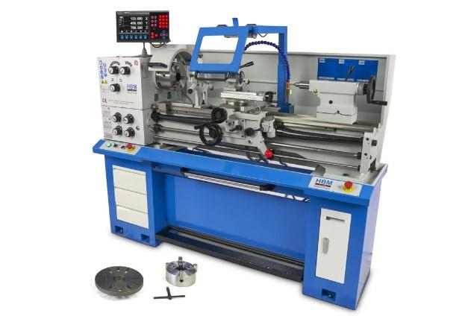
Structure & Precision | Lathe bed | Prism-shaped, cast steel
 | Main spindle | Hardened and ground
 | Digital Readout (DRO) | 3-axis LCD
 | Integrated lighting | LED
 | Foot brake | Electromechanics
 | Zero-voltage protection | Yes
 | Chip tray | Yes, removable
 | Cooling system | Included
 | Included accessories | Fixed steady rest, clamping plate, tools
Dimensions & Weight | Width | 76 cm
 | Height | 160 cm
 | Length | 193 cm
 | Product dimensions | 193 cm x 76 cm x 160 cm
 | Footprint | 193 cm x 76 cm x 160 cm
 | Packaging dimensions | 192 cm x 76 cm x 156 cm
 | Net weight | 630 kg
 | Center height | 18 cm
 | Bed width | 18,7 cm
Working Area | Distance between centers | 1000 mm
 | Swing over bed | 36 cm
 | Swing over cross slide | 17 cm
Spindle & Taper | Spindle bore | 50 mm
 | Spindle mount | Camlock D1-5
 | Tailstock taper | MC3
 | Tailstock quill travel | 10 cm
Carriage Movements | Compound slide travel | 10 cm
 | Cross slide travel | 17 cm
Threading | Metric thread range | 0,4 – 7 mm
 | Imperial thread range | 4 – 56 TPI
Tooling | Tool size | 16 x 16 mm
Transmission | Motor power | 1500 W
 | Operating speed range | 70 – 2000 rpm
Power Supply | Voltage | 400 V
Price | €5999.99
Pag. 36 | 68
TOOLS:
Tools | Name | Dimension  [mm] | Price [€]
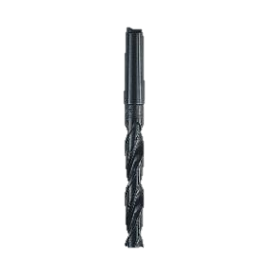 | HSS Drill Bit DIN 345 with Taper Shank – Krino Morse | Ø 24 | 28,90
 | PRO Metal HSS-G Metal Drill Bit | Ø 6 | 23,00
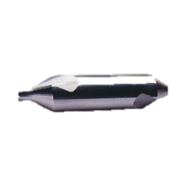 | Center drill P056/2.5 | Ø 2.5 | 4,06
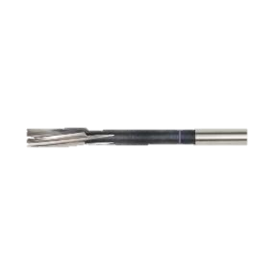 | Reamer for NC machine H7  HSCO-WN-H7-D6.0-L93/26 | Ø 6 | 16,38
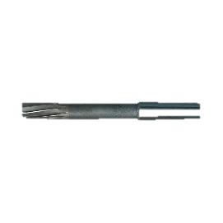 | Machine reamer  A208B/24 | Ø 24 | €54,50
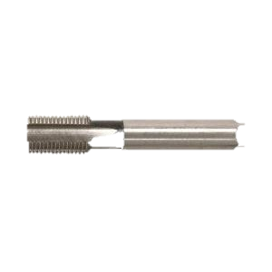 | Machine tap 6131 G 3/4 GAS WSG HSS-E | G 3/4 | €81,44
Pag. 37 | 68
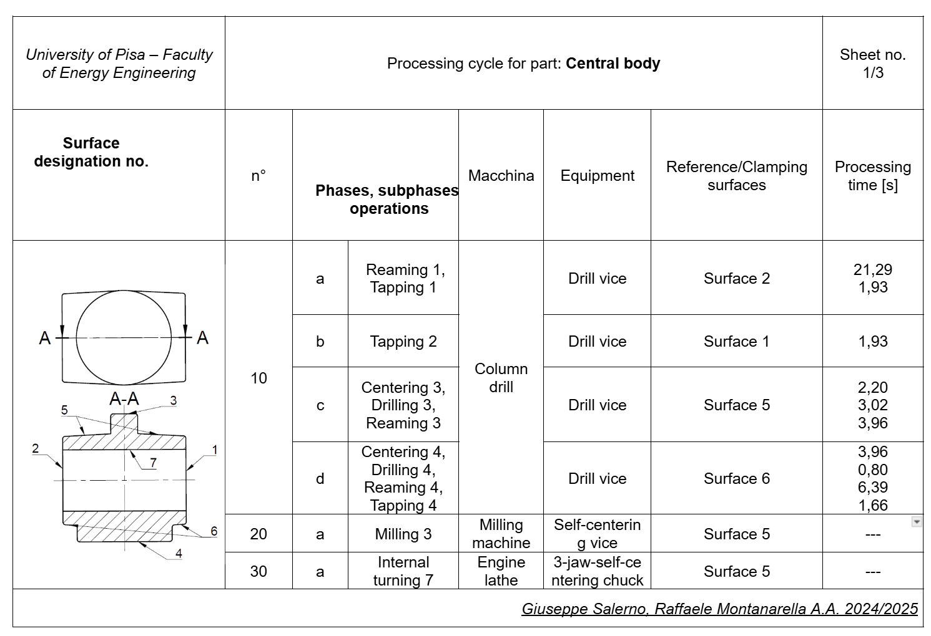
Process sheet:
:

For the main body of the valve, we decided to further investigate the drilling, boring, and tapping operations (step 10).

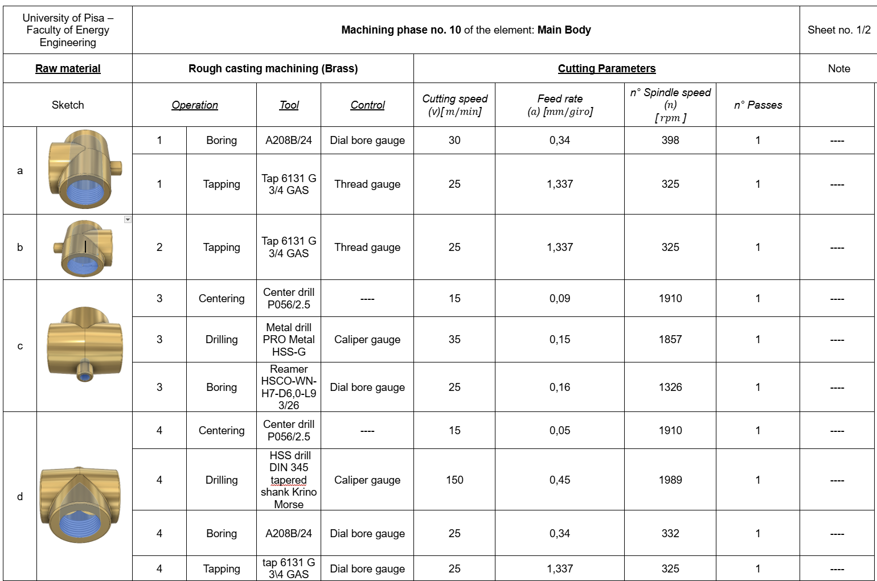

Pag. 38 | 68
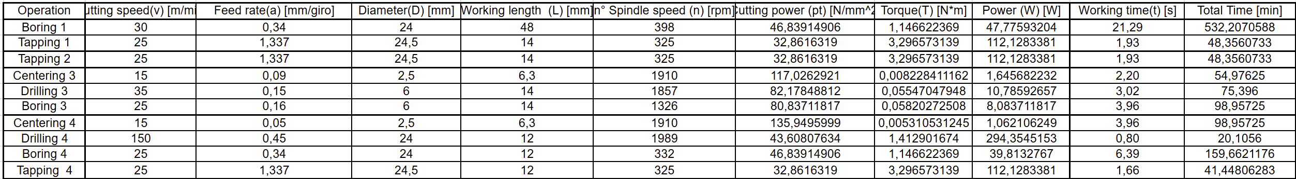
We calculated the values shown in the cycle and phase sheets using the formulas and tabulated data from Santochi, listed in the following spreadsheets.
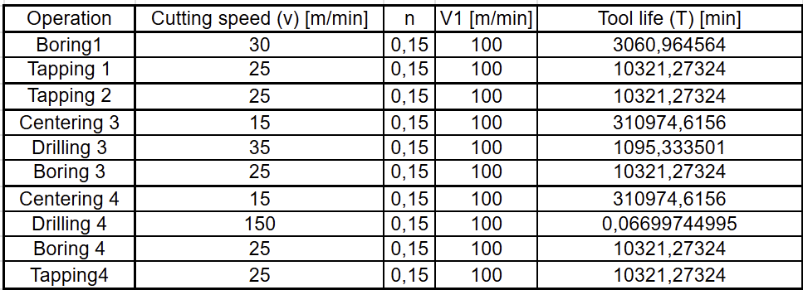

The relationships we used are the following:
$Cutting pressure p_{t}=p_{s}{\left(a∙D\right)}^{-\frac{1}{n}}$,$con p_{s}= 80\frac{N}{mm2}$ $e \frac{1}{n}=0.255$
$$Torque T=p_{t}∙ \frac{a∙D}{28000}$$
$$Power W=T∙\frac{2πn}{60}$$
$$Power W= T⋅\frac{2πn}{60}$$
$$Tool life { T=\left(\frac{V_{1}}{v}\right)}^{\frac{1}{n}} , con V_{1}=100m/min, n=0.15$$
We note that tool wear still allows the production of the 1,500 valve bodies, except for the HSS DIN 345 ∅24 mm drill bit, which must be resharpened approximately every 5 cycles to ensure the cutting edge remains sharp and no hole defects occur. However, since resharpening reduces the drill length, we chose to purchase 10 drill bits, so that each bit can be resharpened 30 times before becoming obsolete.
Pag. 39 | 68
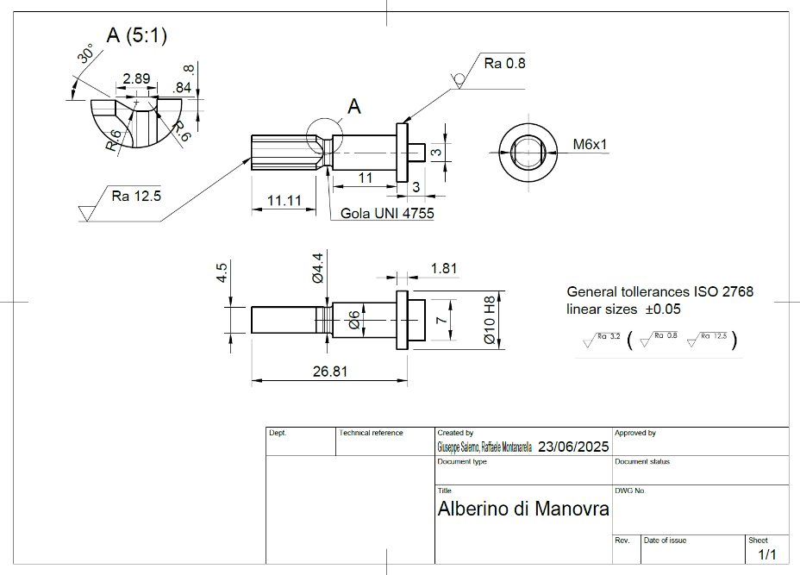
CONTROL SHAFT:

From the drawing of the control shaft, we see that the optimal raw material for producing it is a calibrated Ø10 mm rod, so we can start from a cylindrical blank whose size matches the shoulder that will fit into the groove of the valve body.
We therefore chose 6-meter AISI 304 steel bars (standard commercial length), which will be cut to a length of 30 mm, forming the base for the following machining operations.
First of all, since there is a diameter reduction (shoulder) and a threading with a relief groove, parallel lathe machining is required.
Additionally, the pinning near the thread and the parallelepiped-shaped shoulder—which enables torque transmission from the actuating lever to the ball—require the use of a universal milling machine.
The machine tools used are the same as those used for the valve body.
These are the tools and inserts we will use:
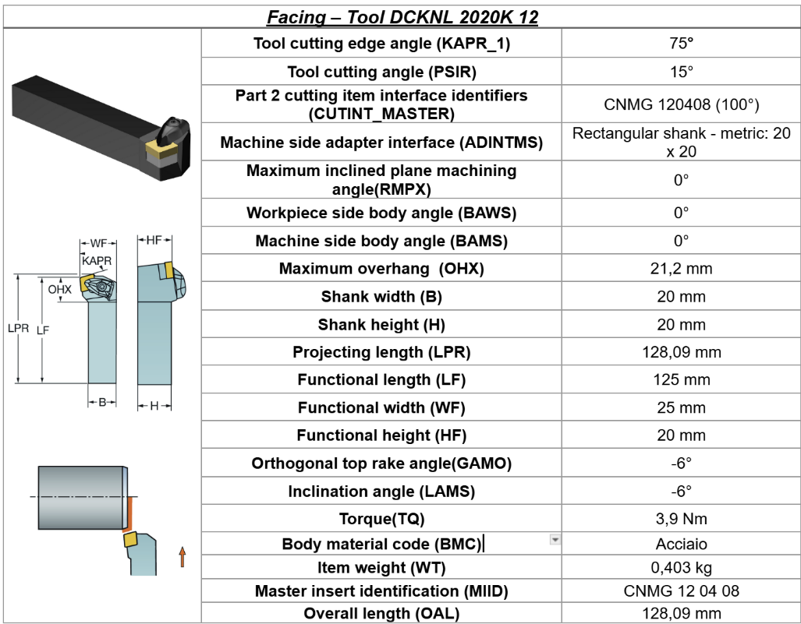

Pag. 40 | 68
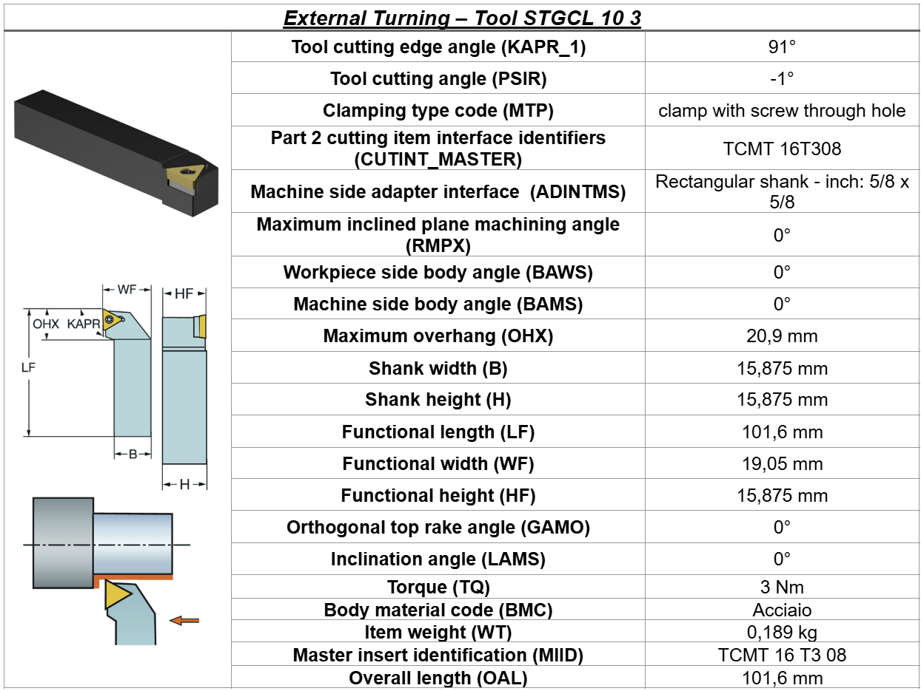
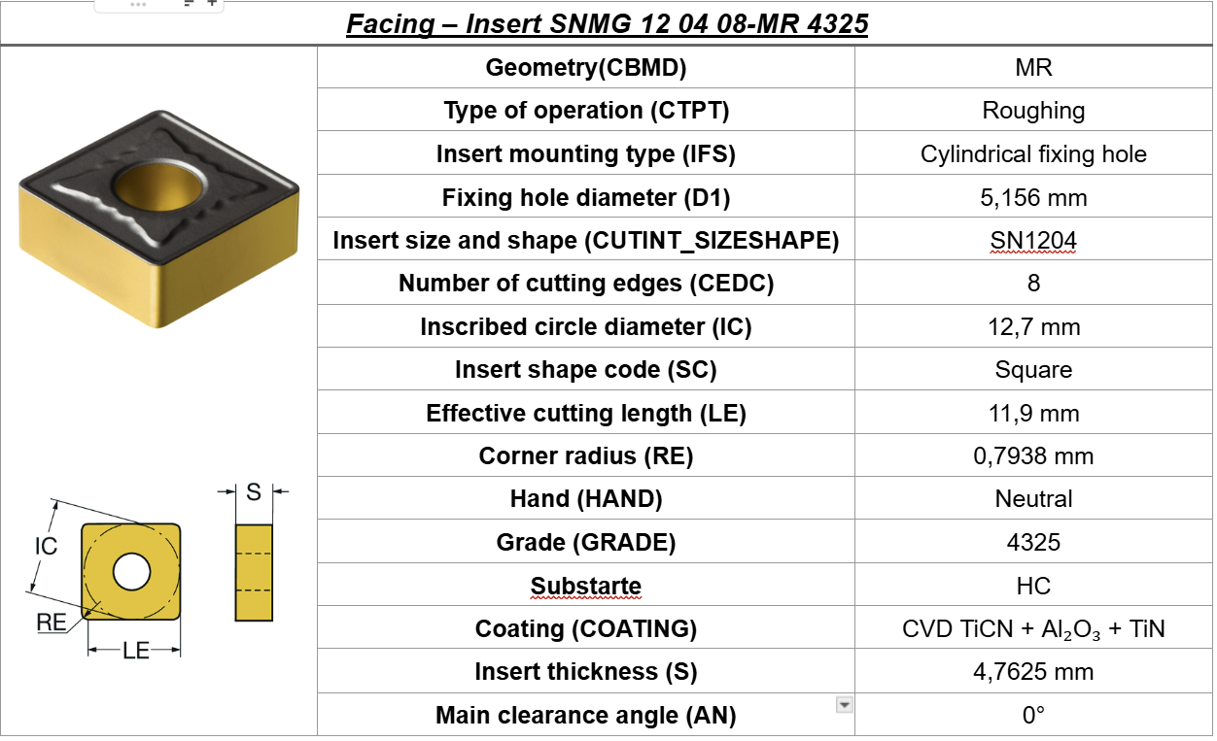
Pag. 41 | 68
Pag. 5 | 68
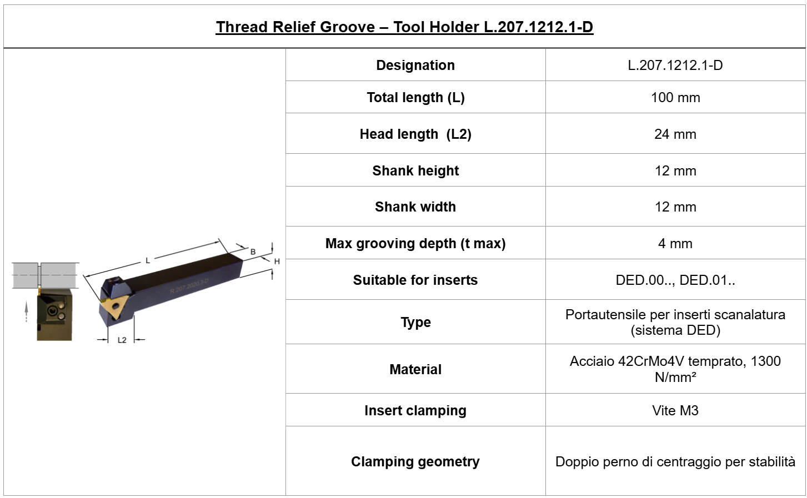

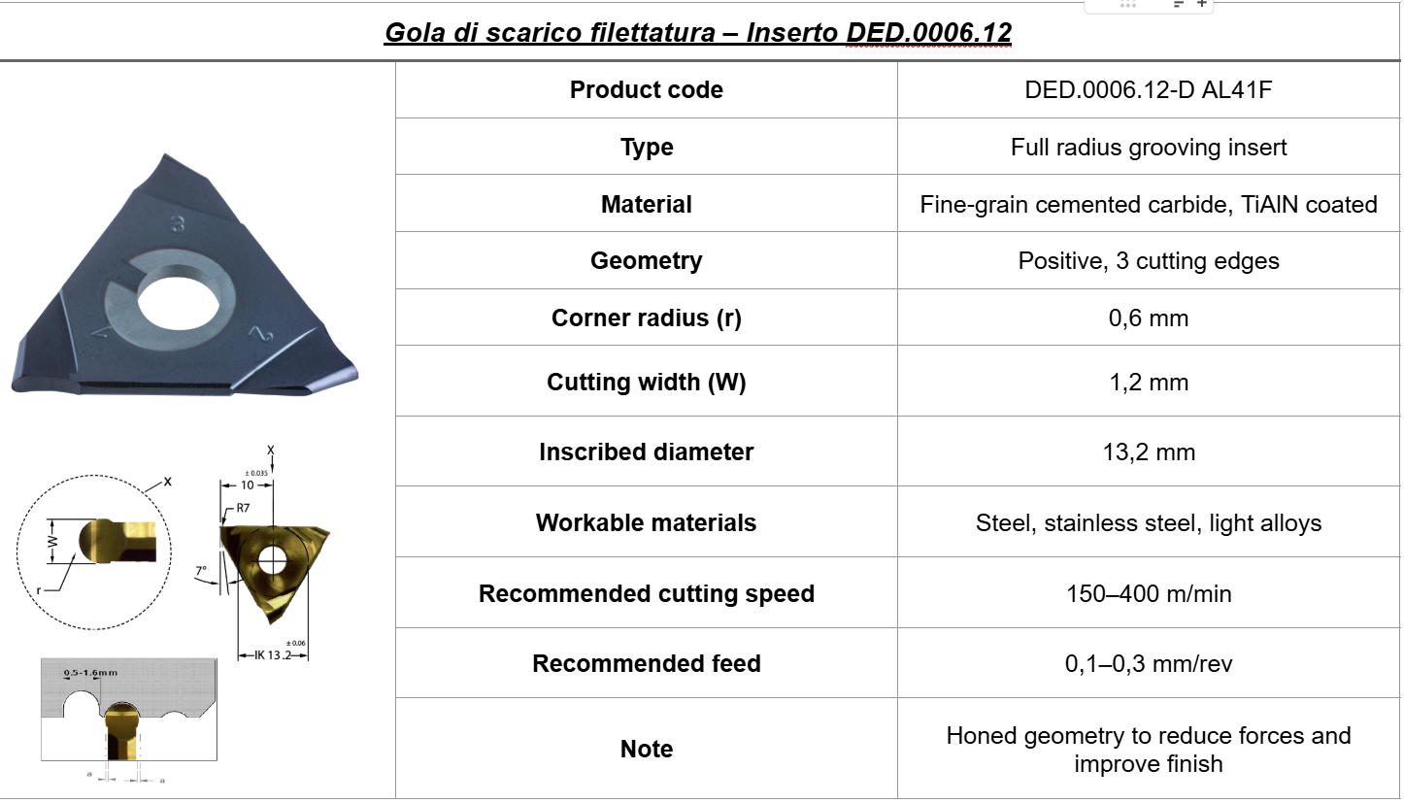
Pag. 42 | 68
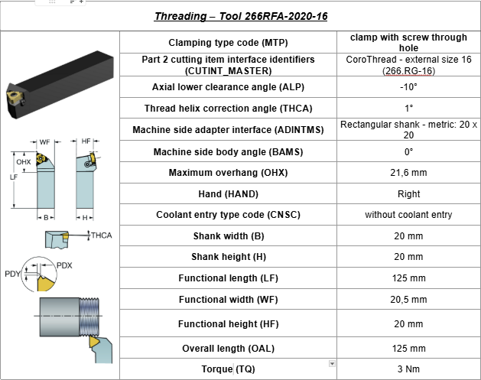

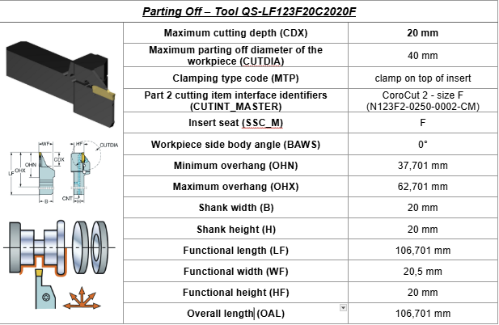

Pag. 43 | 68
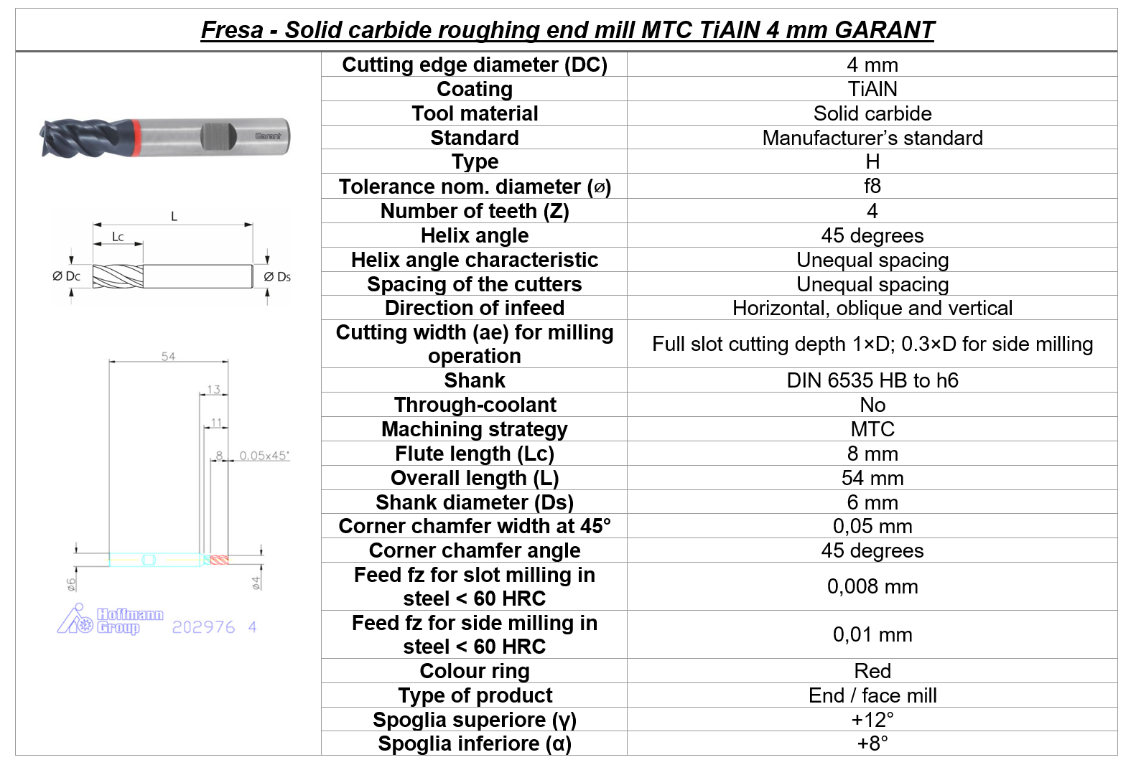

We can now draw up the process sheet:
For the operating shaft, we will cover the machining operations on the parallel lathe

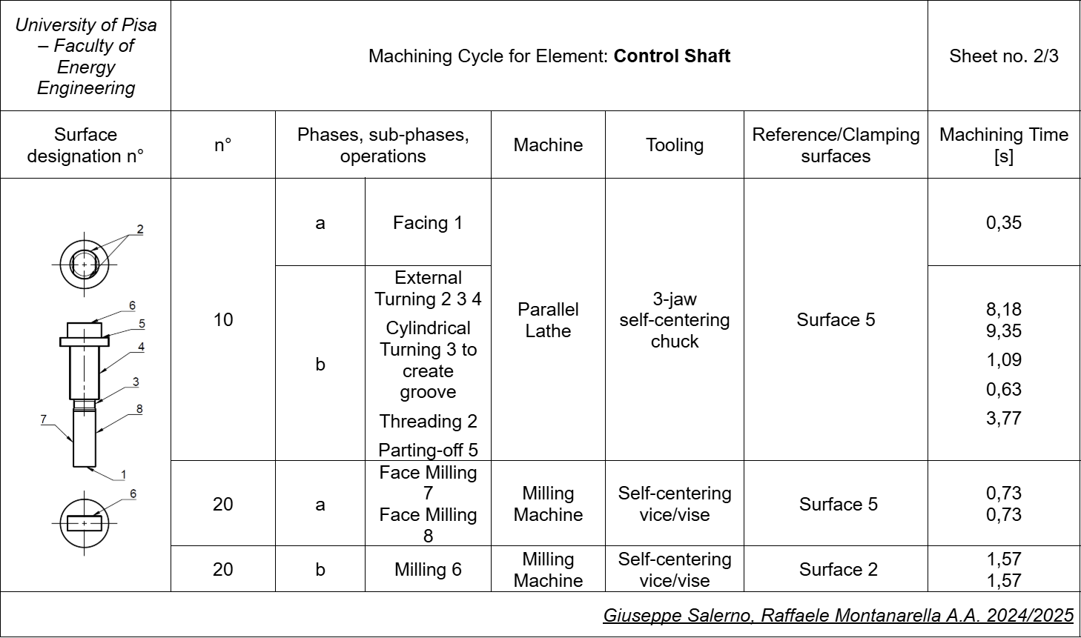

Pag. 44 | 68
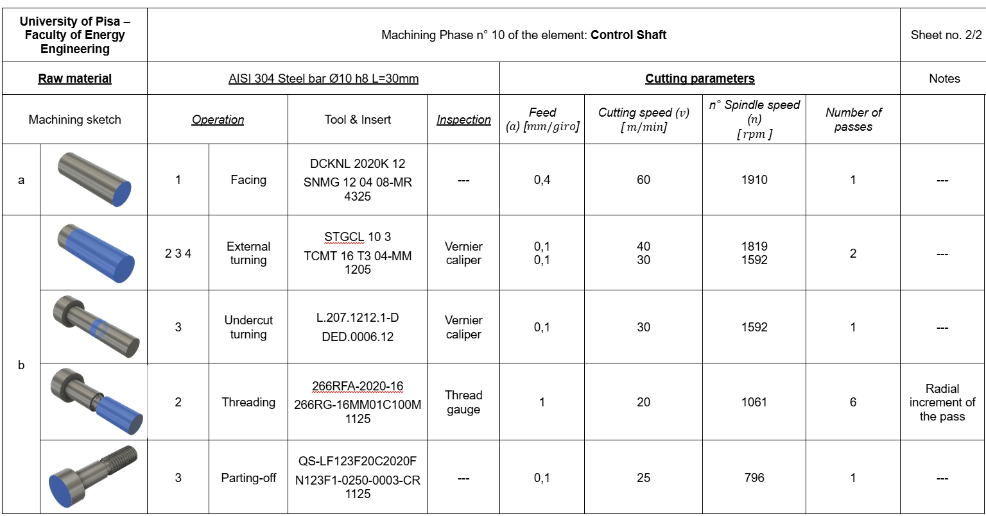

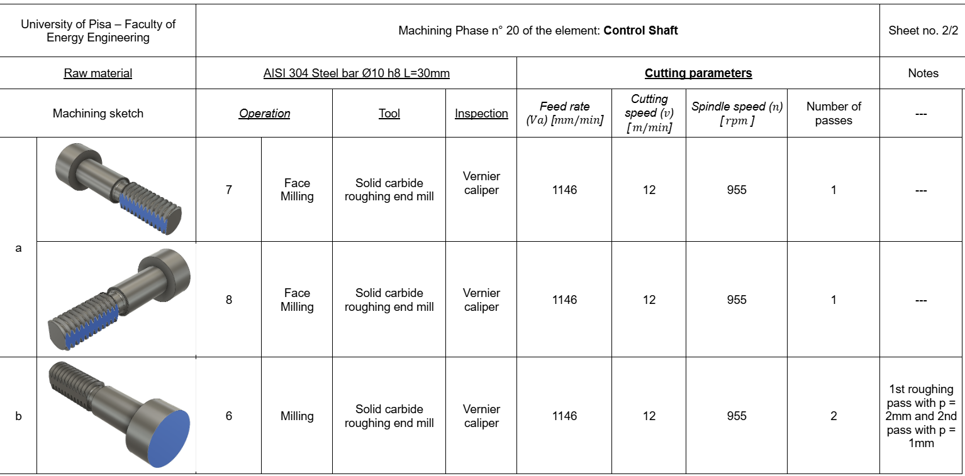

Also in this case, we calculated the values shown in the process sheets and phase sheets using the formulas and the tabulated data from Santochi, listed in the following spreadsheets:

Pag. 45 | 68
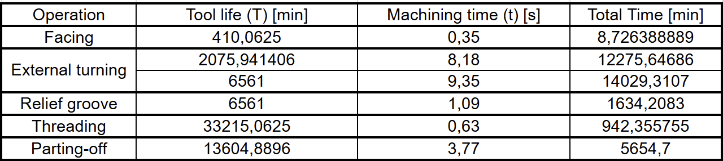

The common formulas we used are:
$$Spindle angular speed n=\frac{1000⋅v}{π⋅D}$$
$$Kronenberg's formula for steels p_{s}=2.4⋅Rm^{0.454}∙β^{0.666}$$
$$where R_{m}=600\frac{N}{mm^{2} } e β=\frac{π}{2}-α+γ \left[rad\right]$$
$$Tool life { T=\left(\frac{V_{1}}{v}\right)}^{\frac{1}{n}} , con V_{1}=270m/\min{e n=0,25}$$

For turning:
$$Main cutting force\left[N\right] F_{z}=p_{s}{\left(a∙p\right)}^{1-\frac{1}{n}}$$
$$Torque T=F_{z}∙\frac{D}{2}$$
$$Power P=F_{z}⋅v$$
$$Schmalz's approximate formula R_{a}=\frac{a^{2}}{32r}∙{10}^{3}$$
$$Machining time t=\frac{L}{a∙n}$$
For milling:
Pag. 46 | 68
$$Feed rate V_{a}=a_{z}⋅n⋅Z= 12 m/min con a_{z}=0,3mm e Z=4$$
$$Cutting pressure p_{t}=p_{s}∙{\left(a∙p\right)}^{-\frac{1}{n}}$$
$$Average cutting force T_{med}=p_{t}∙l∙\frac{V_{a}}{n∙Z}∙\sqrt{\frac{p}{D}}$$
$$Average cutting power W_{med}=\frac{T_{med}∙v}{60}$$
$$Machining time t=\frac{L^{'}}{V_{a}}$$
From Taylor's equation, we observe that the only insert whose wear does not allow the production of all 1,500 operating shafts is the TCMT 16 T3 04-MM 1205, of which at least 6 inserts are needed.
ADJUSTMENT RING:

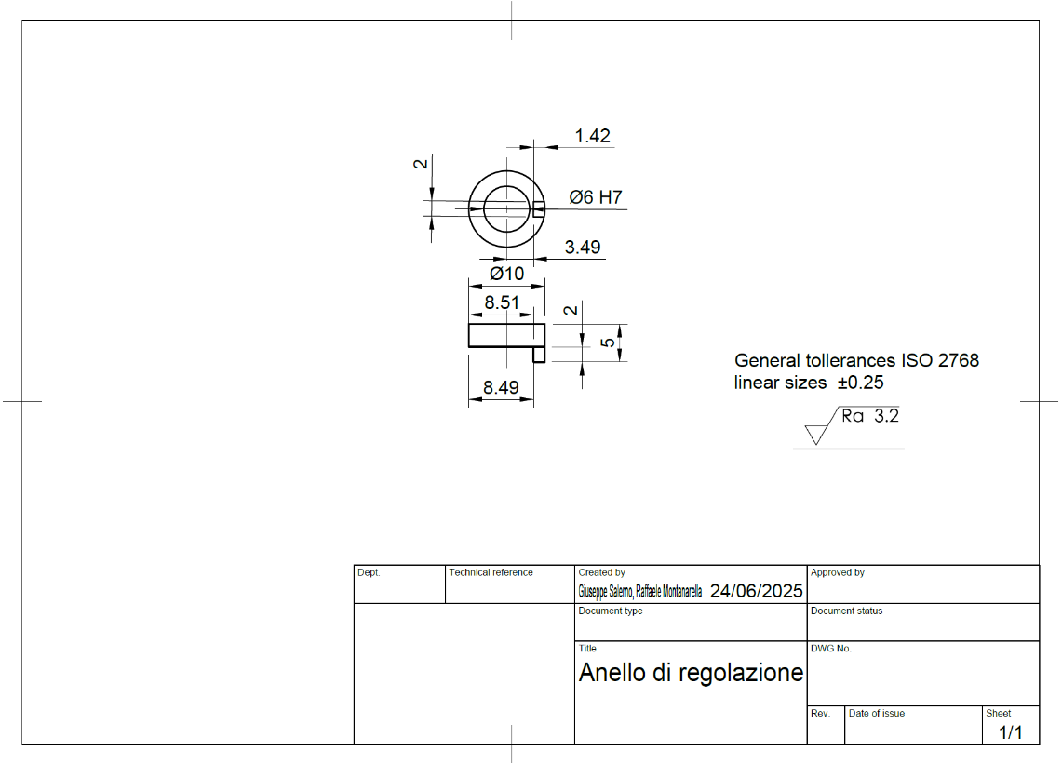

From the drawing of the adjustment ring, we observe that it is necessary to start from a cylindrical bar, which this time does not need to be ground, since the outer surface is not a functional surface.
To manufacture it, however, it will be necessary to drill and bore the starting cylinder and then carry out on the milling machine a shoulder cut that leaves the small section which will allow the lever, once it is welded to the ring, to rotate 180°.
Pag. 47 | 68
Since we have already covered the chip removal operations for the valve body and the operating shaft, we have decided to prepare the phase sheet of the ring only for completeness, without further detailing its machining operations.
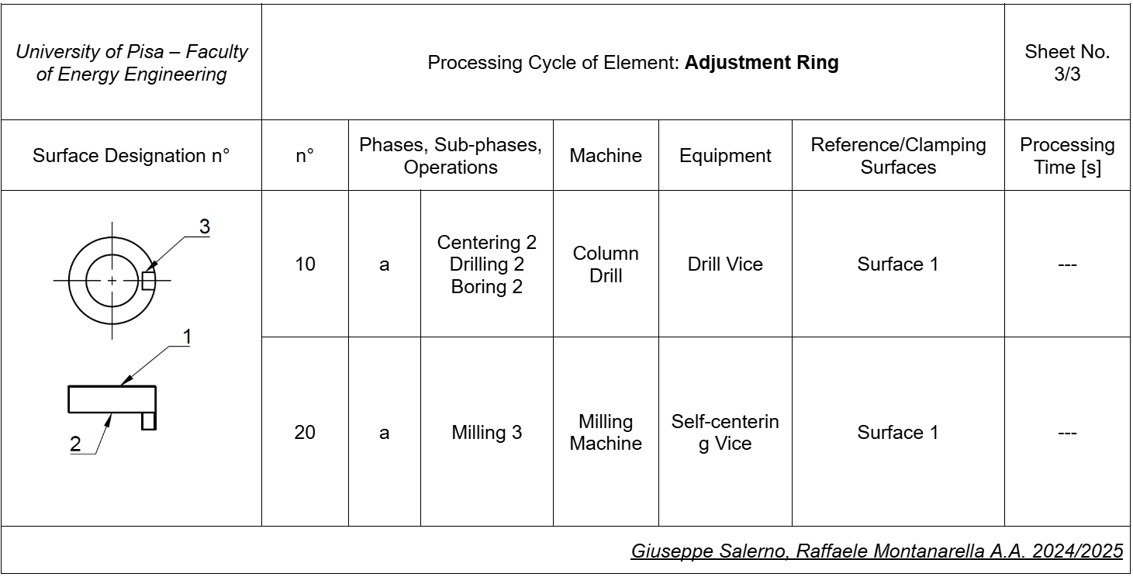

PLASTIC DEFORMATION

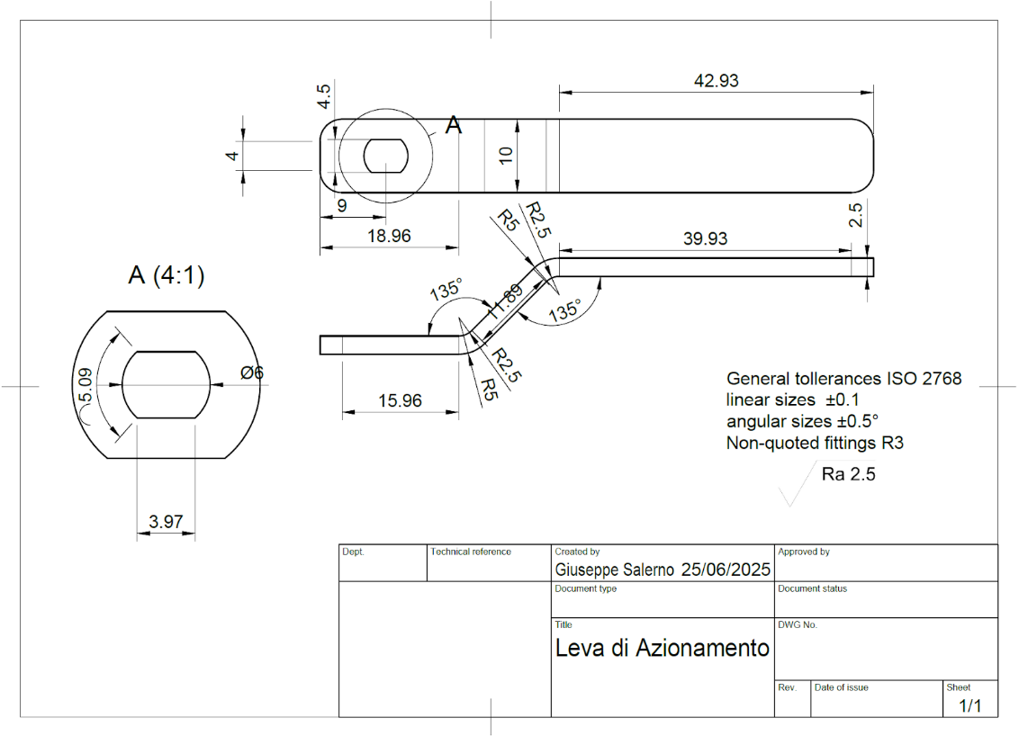
As for the plastic deformation processes, we chose to focus on the valve operating lever, a component that can be easily manufactured—given its geometry and the material it is made of—through the processes of blanking and bending.

Pag. 48 | 68
Let’s start with the material: we decided to use an AISI 304 steel sheet, since the valve may be used in industrial environments, where humidity and the possible presence of acids could promote corrosion of its components.
This choice also ensures weld compatibility between the lever and the adjustment ring.
To manufacture the lever, the sheet metal must first be blanked, and in order to determine the type of machine to use (press or hammer), we first need to estimate the cutting force, which can be done using the following formulas:

$$R_{max}=l_{tot}∙s∙σ_{t} e σ_{t}=\frac{4}{5}R_{m}\left(Santochi\right), con R_{m}=\frac{600N}{mm^{2}}e s=2.5mm$$
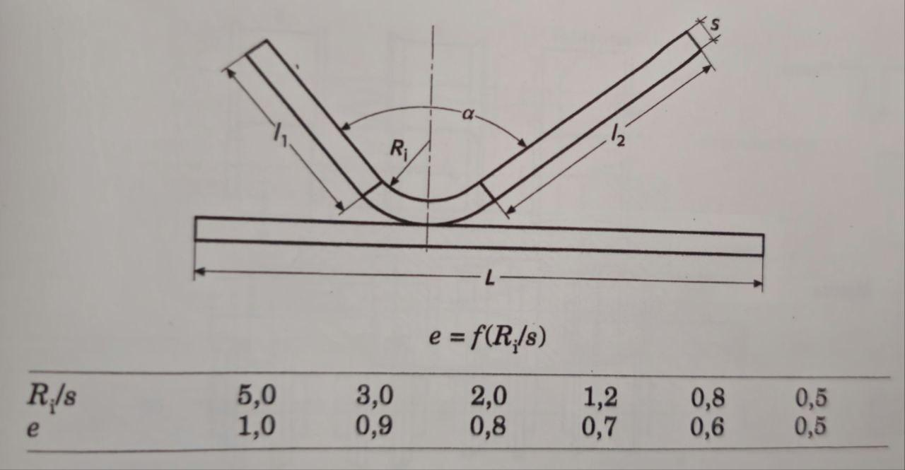
Figura 4.0 piegatura lamiera
$l_{tot}$is the perimeter of the sheared contour.
To calculate it accurately, we must first estimate the flat (pre-bent) dimensions of the sheet metal, using the formula:

$$L=l_{1}+l_{2}+\frac{α∙π}{180}\left(R_{i}+\frac{e∙s}{2}\right)con ⅇ≈0.65 poichè\frac{R_{i}}{s}=\frac{2.5}{2.5}=figura 4.0$$

We then obtain:

$${l^{'}}_{tot}=2\left[3⋅π+11.89+39.93+15.96+\frac{2π∙135}{1805}+\frac{5+2.5∙0.65}{2} \right]≅185.63mm$$
$${l''}_{tot}=2\left(5.09+3.97\right)=18.12mm$$

Where ${l^{'}}_{tot}$ is the outer perimeter, and l″_tot is the perimeter of the hole where the operating shaft will be inserted. Thus we get:
Pag. 49 | 68
$$P_{max}=\left(185.63+18.12\right)⋅2.5⋅\frac{4}{5}⋅600=244.5 kN$$
The corresponding available energy is $E=P_{max}.s=244.5⋅2.5≅0.61 kN⋅m$
A hammer would be excessive for this operation, so we opted for an eccentric press, since the required force is
$$F=\frac{P}{g∙{10}^{3}}=\frac{244500}{9810}≅25 t$$

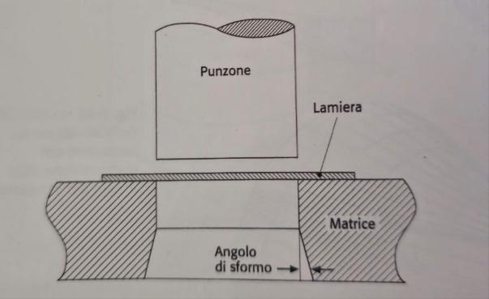
A clearance must also be provided between the punch and the die, calculated using the formula:

$$g=0.002∙S∙σ_{t}^{0.5}$$
$$=0.002⋅2.5⋅{\left(\frac{4}{5}⋅600\right)}^{0.5}≅0.11mm$$

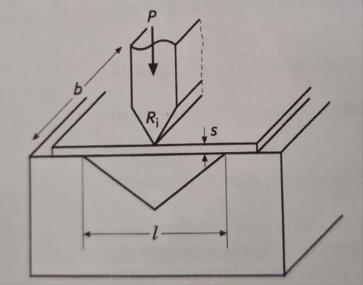
The blanked sheet metal will then need to be bent twice; in both cases, the required bending force is given by the formula:
$$P=\frac{b∙s^{2}∙2Y}{1.5l} con Y=\frac{230N}{mm^{2}}$$

$$s=2.5mm b=10mm,$$

$$Thus P=\frac{10∙{10}^{2}2∙230}{1.5∙10}≅30.7 kN$$

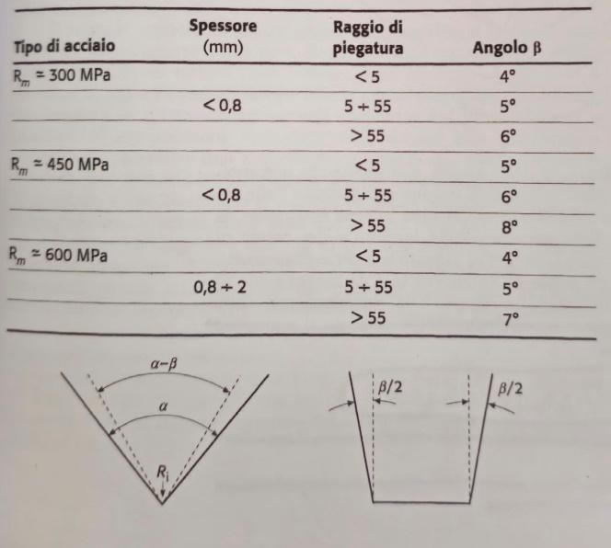
Due to the elastic springback of the material, the bending angle must be overcompensated. Since we're using AISI 304 steel sheet (Rₘ = 600 N/mm², s = 2.5 mm) and the bending radius is 2.5 mm, the actual bending angle must be:
139° instead of 135°

Pag. 50 | 68
ECCENTRIC PRESS:

MIOS Eccentric Press – Model T40 – FV
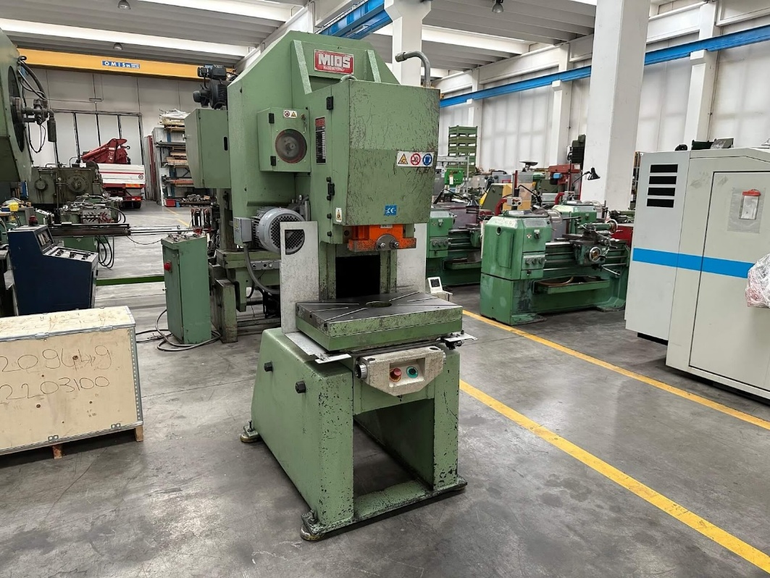 | Technical Specifications and General Features
 | Applied Force | 40 Ton
 | Stroke Range MIN - MAX | 5 – 75 mm
 | Strokes per Minute | 140
 | Motor Power | 4 kW
 | Distance Between Table and Ram (MIN - MAX) | 255 – 330 mm
 | Ram Bore | 38 mm
 | Weight | 2000 Kg
 | Ready to Use Press
 | Equipped with Safety Guards
 | Source: https://utilmeccanica.com/presse-stampaggio/pressa-meccanica-mios-40-ton/

Pag. 51 | 68

SALDATURA
Thanks to the welding process, we will be able to connect the actuating lever to the adjustment ring, which will allow the lever to rotate, enabling three distinct positions, each allowing for diversion or blocking of the flow.
In order for the two parts to be joined, a frontal weld will be performed between the upper perimeter of the ring and the lower part around the hole of the lever.
Given the characteristics of the weld to be performed, we chose the MIG/MAG (Metal Inert Gas / Metal Active Gas) process. This is an arc welding procedure with a consumable electrode, in which the filler material consists of a continuous wire that is fed mechanically through the torch.
The electric arc is established between the tip of the wire and the workpiece, locally melting both the base metal and the wire to form the weld bead.
One of the distinguishing features of this process is the shielding of the molten weld pool by a continuously supplied gas, whose function is to protect the arc and the molten metal from the surrounding atmosphere, preventing oxidation and contamination from nitrogen and moisture.

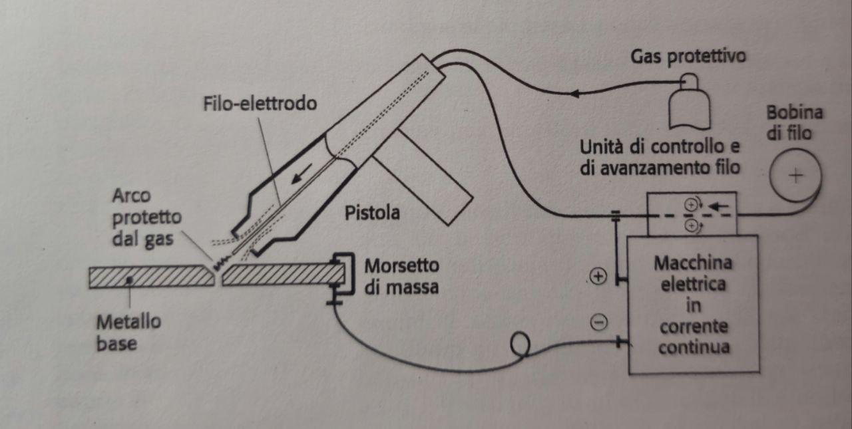
Pag. 52 | 68
The classification between MIG and MAG depends exclusively on the type of shielding gas used:
CLASSIFICATION OF MIG AND MAG
- MIG (Metal Inert Gas): uses inert gases, typically argon or mixtures of argon and helium. It is the preferred method for welding non-ferrous materials such as aluminum, copper, and nickel alloys, where it is crucial to avoid any chemical reactivity between the gas and the metal.
- MAG (Metal Active Gas): uses active gases, such as pure carbon dioxide (CO₂) or mixtures of argon with CO₂ and/or oxygen (O₂). This process is more commonly applied to welding carbon steels and stainless steels, thanks to the greater penetration and arc stability that these gases provide.
From an operational standpoint, the MIG/MAG process is characterized by its high productivity, the possibility of automation (robotic or mechanized welding), and the ease of learning compared to more complex methods like TIG welding. The continuous wire feed enables virtually uninterrupted welding, reducing downtime and increasing production cycle efficiency.
The system requires more sophisticated equipment, consisting of a power source (generally constant voltage), wire feeder, torch, gas cylinder, and a control unit.
Furthermore, the weld quality is strongly influenced by environmental factors: drafts, humidity, and surface contamination can compromise the integrity of the weld bead.
Pag. 53 | 68
Parametri di Saldatura MAG – Giunto a T
Materiale base | Acciaio inossidabile AISI 304
Tipo di giunto | Giunto a T con saldatura a filetto
Tipo di saldatura | Frontale, filetto
Tecnica | Saldatura a punti per bloccaggio iniziale, saldatura a filo continuo
Gas di protezione | 75% CO₂ / 25% Argon (miscela attiva – buon compromesso costo/qualità)
Diametro filo | 0,8 mm
Tensione di saldatura | 18 – 22 Volt
Corrente di saldatura | 50 – 90 Ampere
Velocità di alimentazione filo | 6 – 9 m/min
Velocità di avanzamento | 250 – 350 mm/min
Stick-out (sporgenza filo) | 12 – 15 mm
Posizione di saldatura | Posizione piatta (PA) o orizzontale (PB)
STAHLWERK MIG MAG

Technical Data Sheet – STAHLWERK MIG MAG 200 Spot Puls Pro
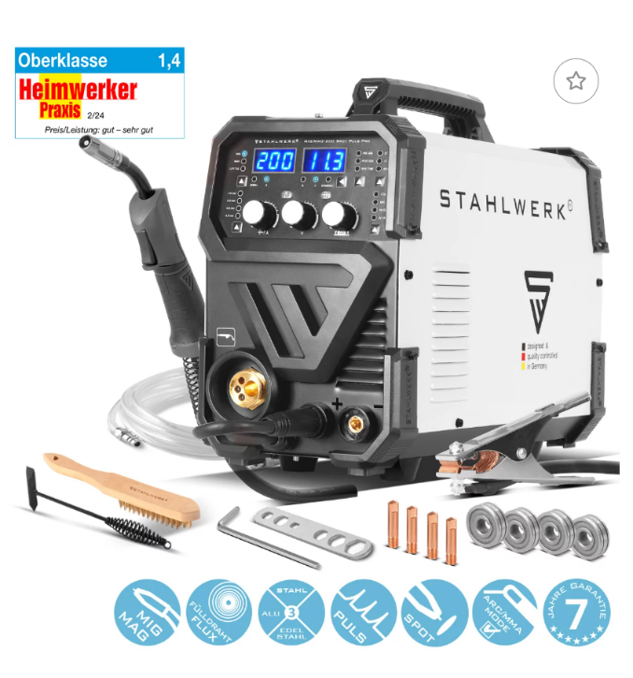 | Supported Processes | MIG/MAG, MIG Pulsato, Spot, MMA/ARC, Lift-TIG, Flux-Cored
 | Technology | Inverter IGBT sinergico, 4 rulli traina filo, regolazione pre/post-gas
 | MIG Current Range | 50 – 200 A
 | MMA / TIG Current Range | 20 – 180 A
 | Duty Cycle (MIG) | 15% @ 200 A / 100% @ 77 A
 | Input Voltage | 230 V ±15%, 50/60 Hz
 | Wire Compatibility | Ø 0,6 – 1,2 mm (ideale Ø 0,8 mm)
 | Operational Controls | Digital display, Synergic/manual adjustment, Inductance, Spot/Pulse
 | Mode Selector | 2T / 4T / Spot
 | Special Functions | spot time, adjustable post-gas, Pulsed MIG, inductance adjustment.
 | Gas Compatibility | CO₂, Argon, miscele (es. 75% CO₂ / 25% Ar) – ideale per AISI 304
 | Weight | 10,8 kg
 | Dimensions (L × P × H) | 460 × 210 × 350 mm
 | Protection and Certifications | IP21S, EN 60974-1, EN 60974-10 Class A, certification SGS
 | Recommended Use | Stainless steel welding, aluminium, carbon steels – professional use.

Pag. 54 | 68
COMPONENTS TO BE PURCHASED
Below are the technical drawings and descriptions of the components that we will not produce ourselves but rather purchase to complete the valve. These are fundamental for its operation and for completing the report with production costs.

SPHERE

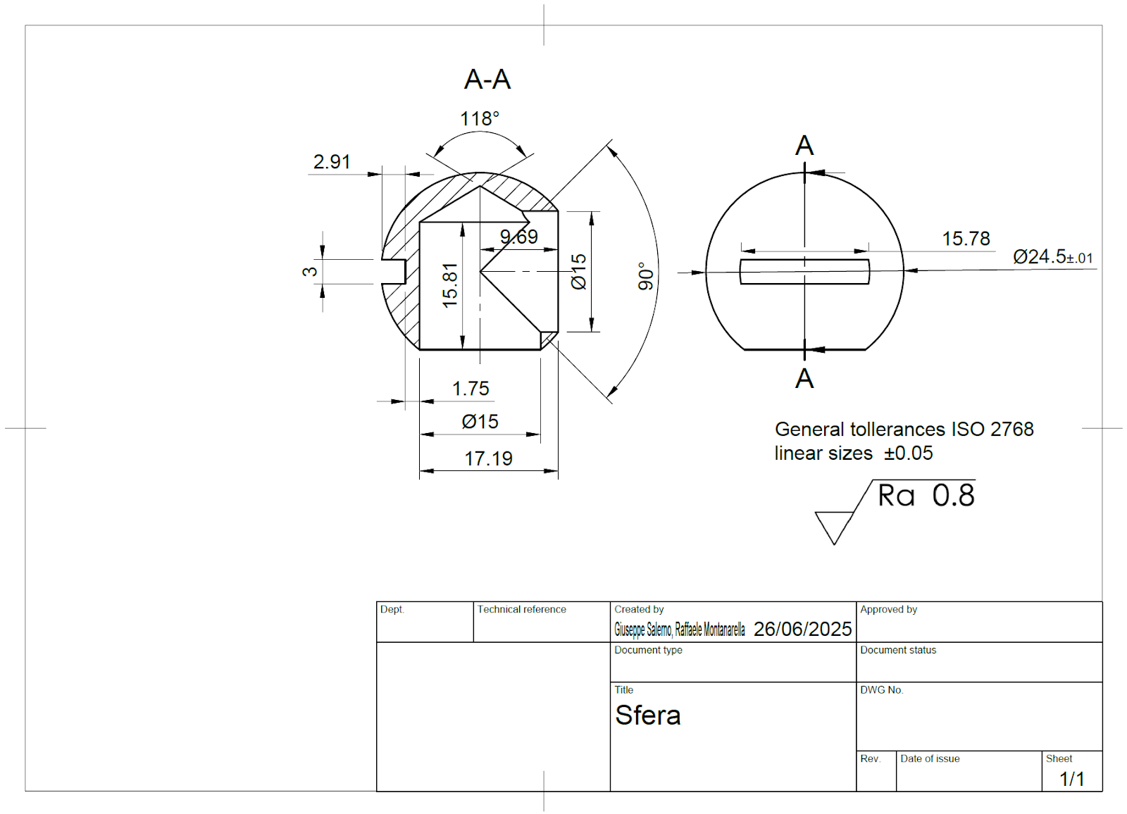

The sphere is the component that allows the flow deviation through the rotation of the lever, which transmits the torque to the sphere via the operating shaft. It is made of AISI 304 stainless steel to ensure corrosion resistance. This is a component that can be easily purchased as there are various types of valves for which it is sold as a spare part

Pag. 55 | 68
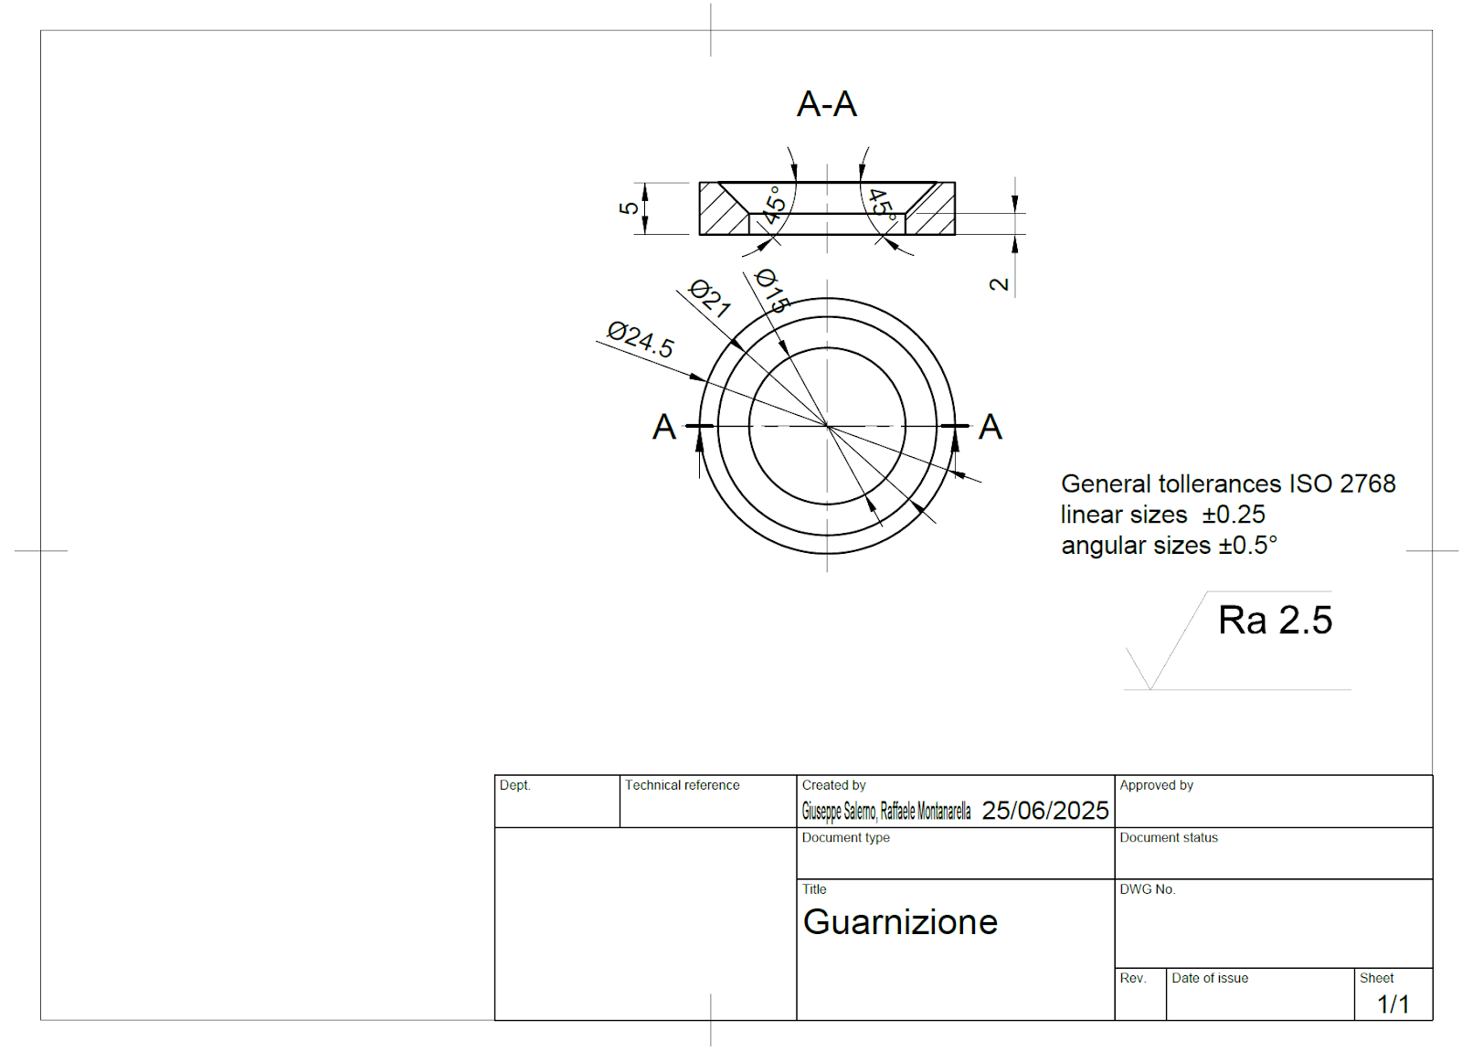
GASKET

The gasket is the component that ensures the seal of the valve. It's also easily purchasable and is made of Viton, a versatile material that is well-suited for this type of component. Its technical data sheet is provided below.

Viton
Operating Temperature | -20 °C a +200/250 °C (fino a +300 °C per brevi periodi)
Chemical Resistance | Excellent: oils, fuels, solvents, acids, hydrocarbons
Hardness (Shore A) | Typically, 60 – 90
Compression set | Very low (excellent long-term sealing)
Ozone and UV Resistance | Excellent
Gas Permeability | Very low
Typical Coloration | Black (but also available in green, brown, etc.)
Wear Resistance | Good
Cold Elasticity | Limited (-20 °C: subject to stiffening)
Fire Retardant | Good fire resistance; not easily flammable
Pag. 56 | 68
NIPPLE
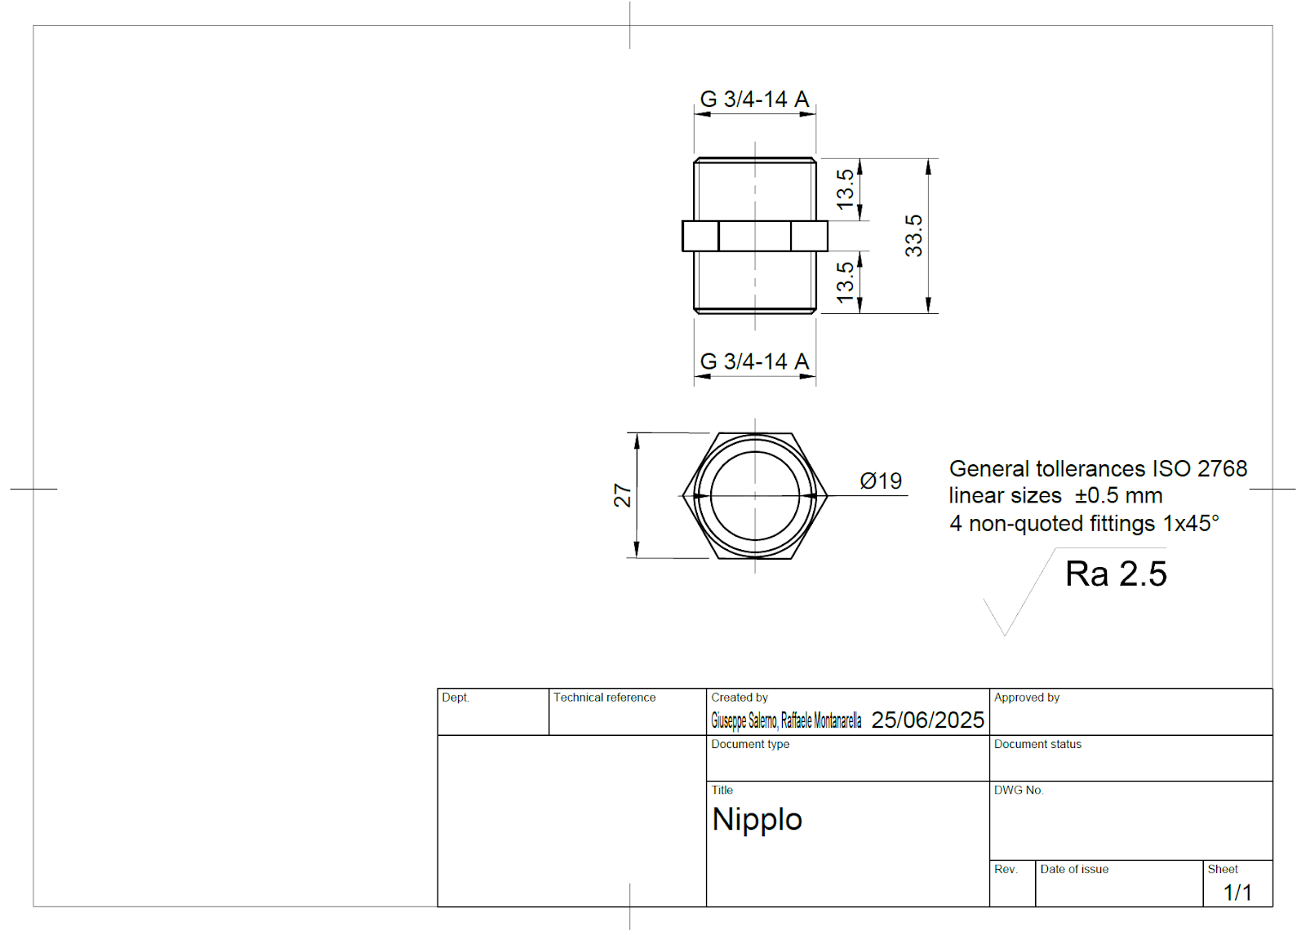

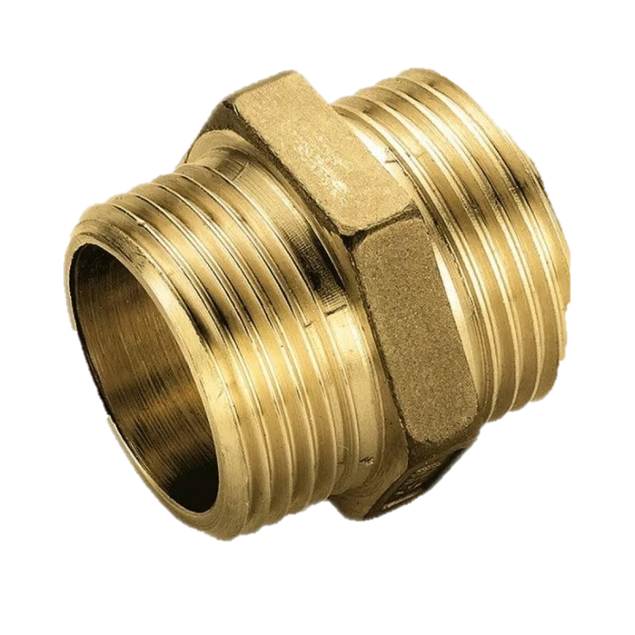

The nipple allows the gaskets to be secured inside the valve and is of fundamental importance for inserting the valve into civil and/or domestic systems. They are made of brass, a material already used for the valve body, whose advantages we have discussed. There is a wide range of choices available on the market for purchasing them.

Pag. 57 | 68
PROCESSING TIME
Let's now try to estimate how much time is needed to produce a complete valve, and from this, estimate the total time for all 1500 pieces. We'll start with chip removal (machining), for which we have tabulated data regarding passive times (Santochi).
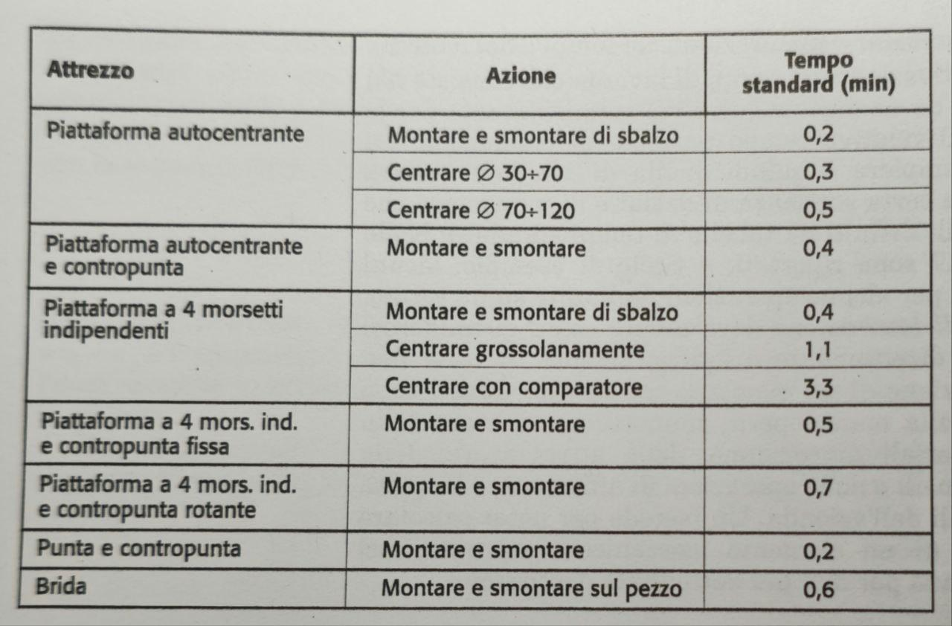
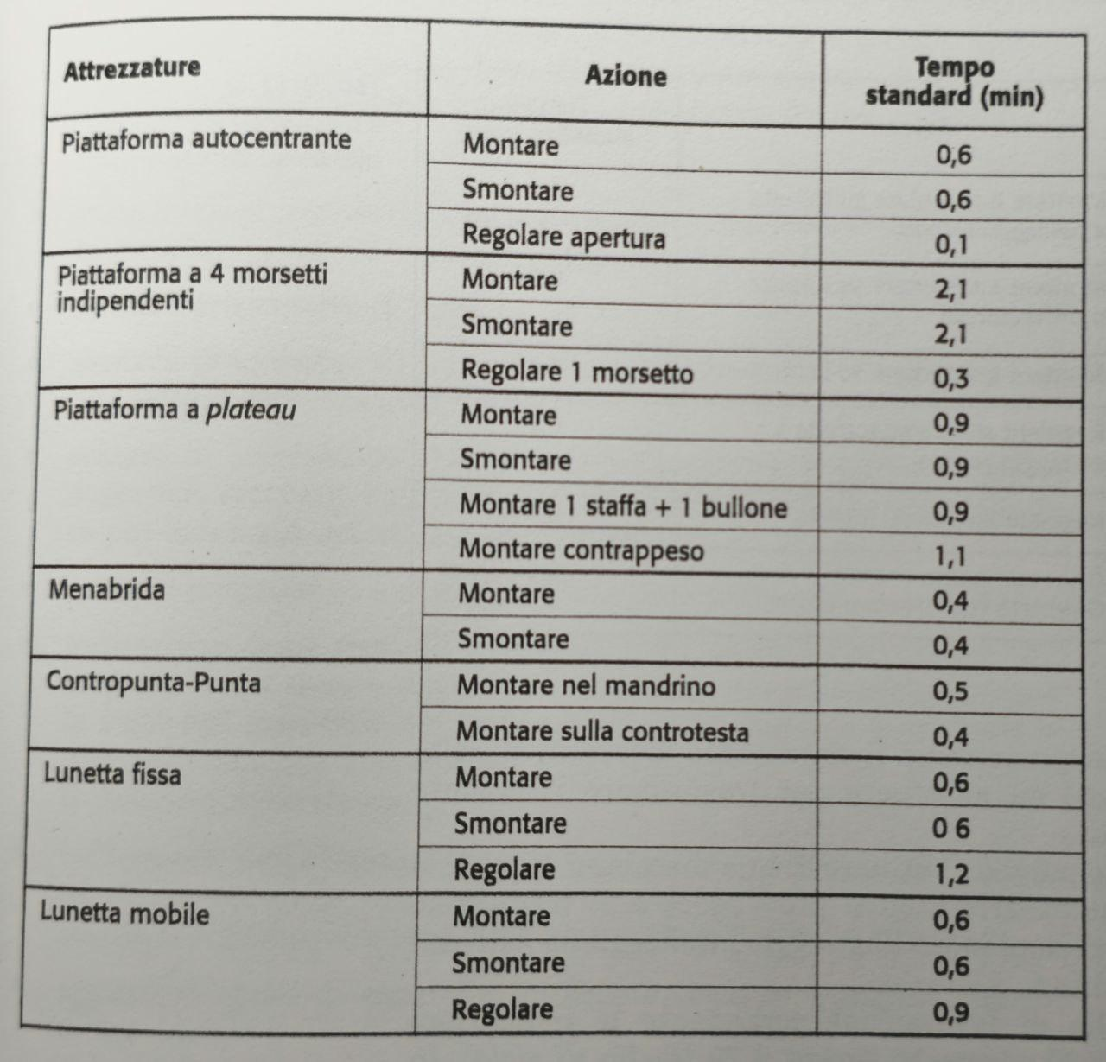
Pag. 58 | 68
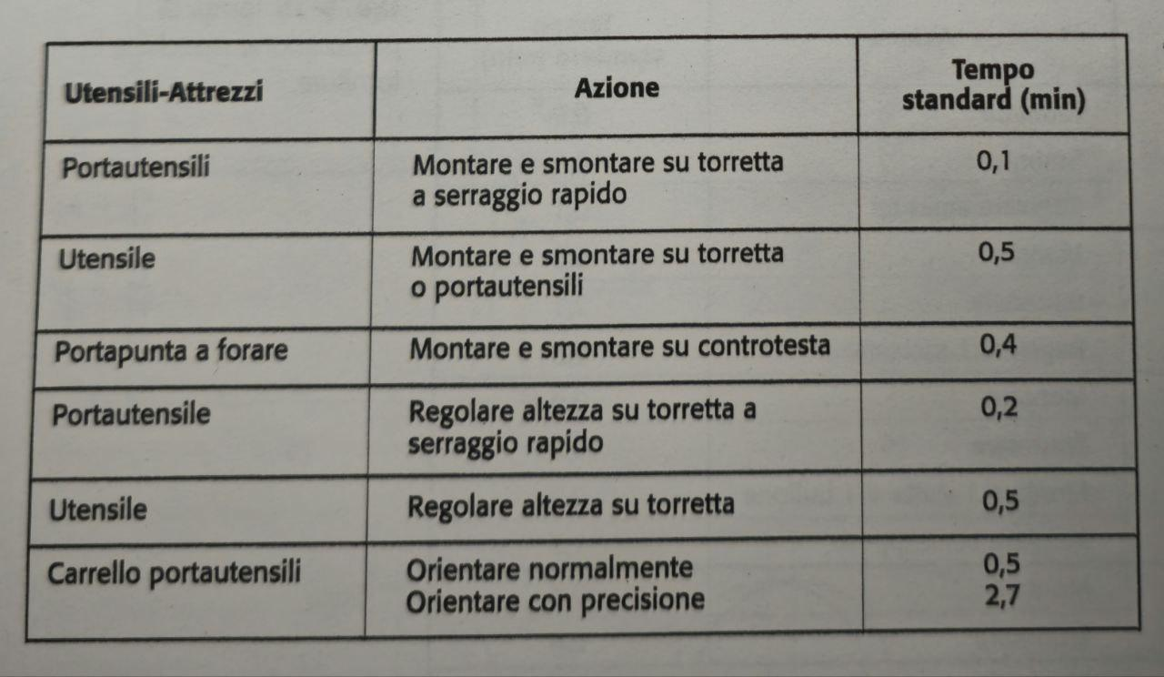

We therefore obtain the following:
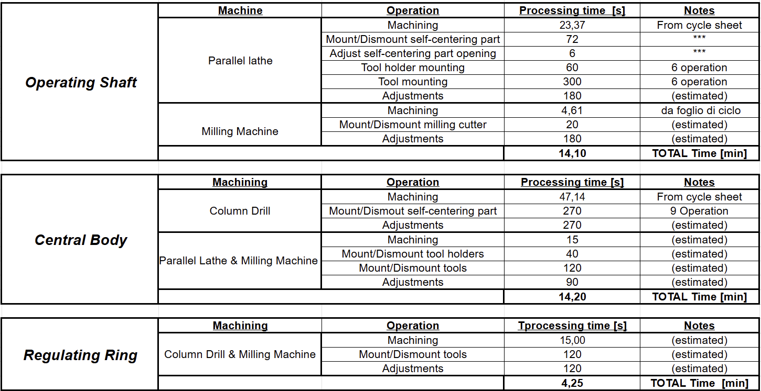

For the other processes, we can estimate the times as follows

We thus obtain a total time of 61.95 min per piece, and therefore approximately 1550 hours for the batch.
This is obviously a value to be taken with a grain of salt, as it does not account for any downtime due to machine maintenance or any unforeseen events during operations, but it is still a good estimate.
Pag. 59 | 68
PROCESSING COST
Regarding costs, we need to make several considerations: let's start first with the raw materials to obtain the different components.
Picture | Raw Material | Quantity | Unit Cost | Cost
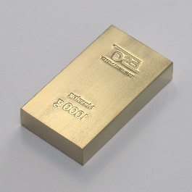 | Foundry Brass | 825 Kg | €5,00/Kg | €4125,00
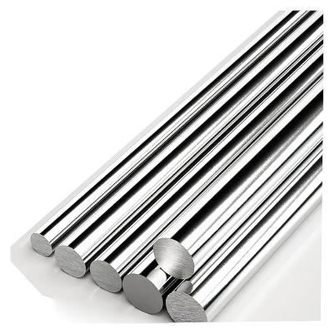 | AISI 304 Steel Bar Ø10mm ground | 15 bars | €47,93/barra | € 719,01
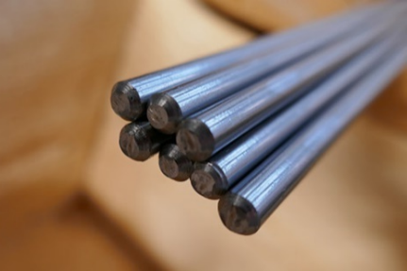 | AISI 304 Steel Bar Ø10mm drawn | 3 bars | €33,04/barra | € 99,11
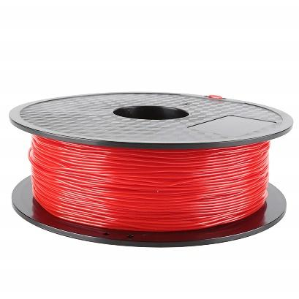 | TPU 1.75 mm Spool | 5 spools | €50/bobina | €250,00
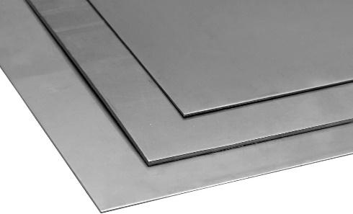 | AISI 304 Steel Sheet 2.5mm thickness 200x200 | 50 Sheets | €10,68/foglio | €250,00
TOTAL COST |  |  |  | € 5. 443,12

Pag. 60 | 68
The quantities are obtained by considering the following. For each body, complete with riser and gating system, approximately 550g of brass are required, from which $0.55 Kg∙1500= 825 Kg$
It is very important to note that thanks to the core, almost 174g of brass were saved per piece.
Given by the formula:

$$M=π⋅r^{2}⋅h⋅ρ=3.14⋅{\left(12mm\right)}^{2}⋅48mm⋅\frac{0.008g}{mm^{3}}≅174g$$
If we hadn't used it, we would have spent an additional €1305 in material alone that would have then been removed, resulting in a consequent increase in processing times and costs for the machine tools
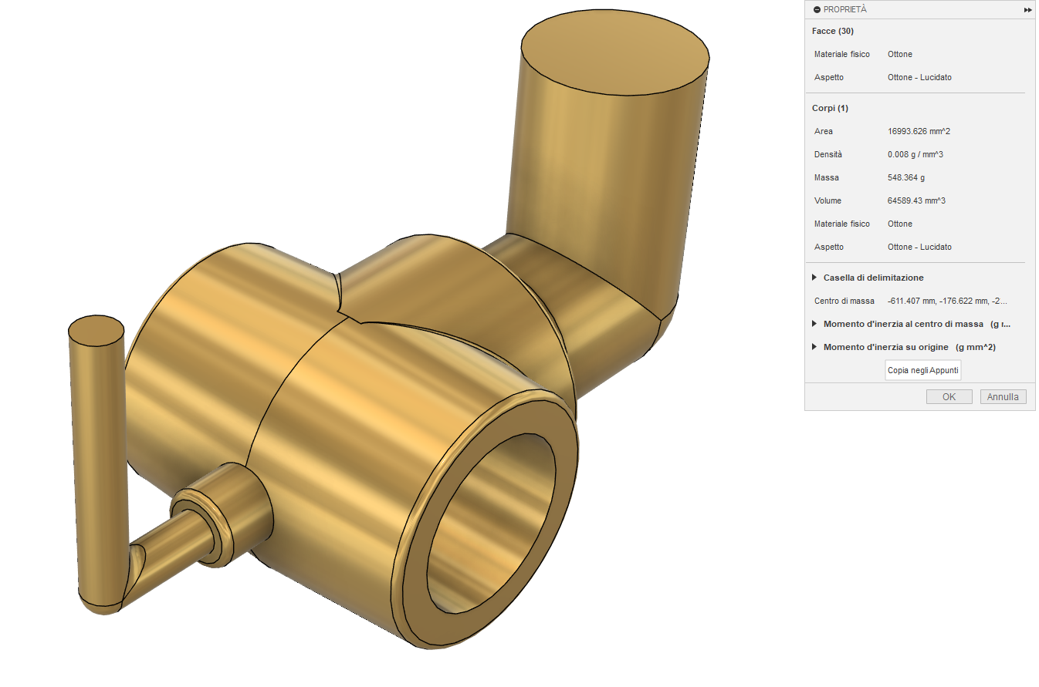

For each operating shaft, a cylinder of 30mm length is required. Since the bars are sold in 3m lengths, 15 bars will be necessary.
For the regulating rings, however, at least 3 bars of 3m will be needed to produce 1550 of them, as each is 5mm in length.
Starting from sheets of AISI 304 steel measuring 200mm x 200mm, and since each lever has an approximate overall dimension of 90mm x 10mm before bending, approximately 44 levers could hypothetically be produced from each sheet. However, the actual number will be lower (each lever has fillet radii and cannot be overlapped in any way, otherwise a different shape would be obtained). We can estimate that at least 30 levers can be obtained from each sheet, requiring 50 sheets in total.
Pag. 61 | 68
ADDITIONAL COMPONENTS TO BE PURCHASED

We must also consider the components to be purchased to complete the valve, namely the spheres, the gaskets, the nipples, and the M6 nuts for fixing the lever to the operating shaft, whose costs can be estimated as follows:
Picture | Name | Quantity | Unit cost | Cost
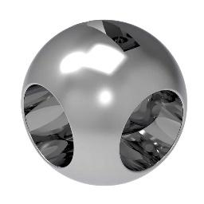 | Sphere | 1500 | €15,00 | € 22.500,00
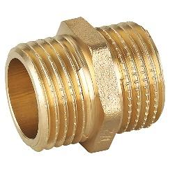 | Nipple | 4500 | €1,93 | € 8.685,00
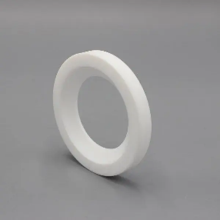 | Gasket | 4500 | €1,50 | € 6.750,00
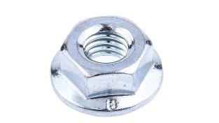 | M6 Flanged Nut | 1500 | €22,51 / 50 unit | € 675.30
TOTAL COST |  |  |  | € 38.610,30

Pag. 62 | 68
MACHINES/TOOLS
Machine | Cost
Die (Casting Mold) and Core | €10.000,00
3-D Printer | €550,00
Parallel Lathe | €6.000,00
Column Drill | €750,00
Milling Machine | €4.500,00
Mechanical Press | €17.000,00
Wire Welder | €550,00
TOTAL COST | € 39.350,00

Per gli utensili, invece, abbiamo visto che ne serve uno di ognuno eccetto per la punta HSS DIN 345 ∅24 mm, di cui ne servono 10 (oltre all’attrezzatura di affilatura) e l’utensile TCMT 16 T3 04-MM 1205, di cui ne servono 6.

Pag. 63 | 68
Tool | Name | Quantity | Price
 | HSS DIN 345 Taper Shank Drill Krino Morse | 10 | €289,00
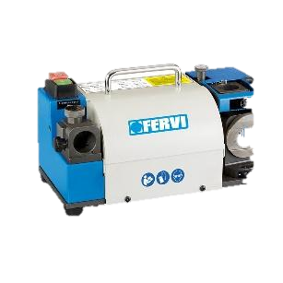 | Twist Drill Bit Sharpener | 1 | €700,00
 | PRO Metal HSS-G Metal Drill Bit | 1 | €23,00
 | Center Drill Bit P056/2.5 | 1 | €4,06
 | NC Machine Reamer H7 HSCO-WN-H7-D6.0-L93/26 | 1 | €16,38
 | Machine Reamer A208B/24 | 1 | €54,50
 | Machine Tap 6131 G 3/4 GAS WSG HSS-E | 1 | €81,44
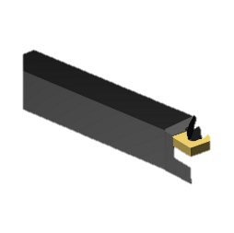 | Tool DCKNL 2020K 12 | 1 | €125,00
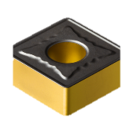 | Insert SNMG 12 04 08-MR 4325 | 1 | €13,00
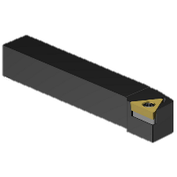 | Tool STGCL 10 3 | 1 | €70,00
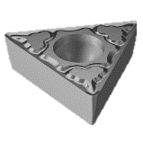 | Insert TCMT 16 T3 04-MM 1205 | 6 | €60,00  Pag. 64 | 68
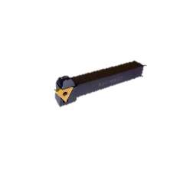 | Tool Holder L.207.1212.1-D | 1 | €67,50
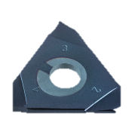 | Insert DED.0006.12 | 1 | €28,10
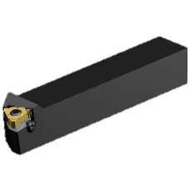 | Tool 266RFA-2020-16 | 1 | €180,00
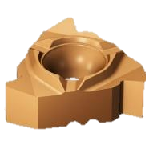 | Insert 266RG-16MM01C100M 1125 | 1 | €24,00
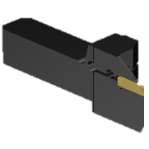 | Tool QS-LF123F20C2020F | 1 | €110,00
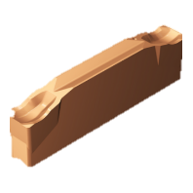 | Insert N123F1-0250-0003-CR 1125 | 1 | €16,00
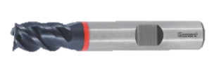 | MTC TiAlN 4 mm GARANT Mill Cutter | 1 | €51,75
TOTAL COST |  |  | € 1.913,73
Here's the English translation of the text, with important words highlighted:
"Summing these values, we obtain a total of €85,317.03. However, to this we must add any costs for electricity and labor (possibly specialized). Having estimated a production time of 1550 hours, we find that for 2 workers performing 8 hours of work per day, approximately 97 working days are needed, equivalent to just over 3 months. Estimating a net salary of €1,800.00 per month (therefore a gross salary of at least €2,500.00) for each worker, we obtain an additional cost of €15,000.00. Assuming potential maintenance and electricity costs around €5,000.00, we obtain a total cost of approximately €105,000.00, meaning each valve costs €70.00. This might seem like a high cost, but given the excellent materials used and the fact that it's the production of a relatively small batch with traditional machines, it is a balanced cost that we expected from the outset. By selling the valve at a price of €80.00, we will achieve a gross profit of €15,000.00 (which, incidentally, equals the workers' salaries), which would then allow us a gross profit of €7,500.00 per person.
Pag. 65 | 68

3D REPRESENTATION VALVE

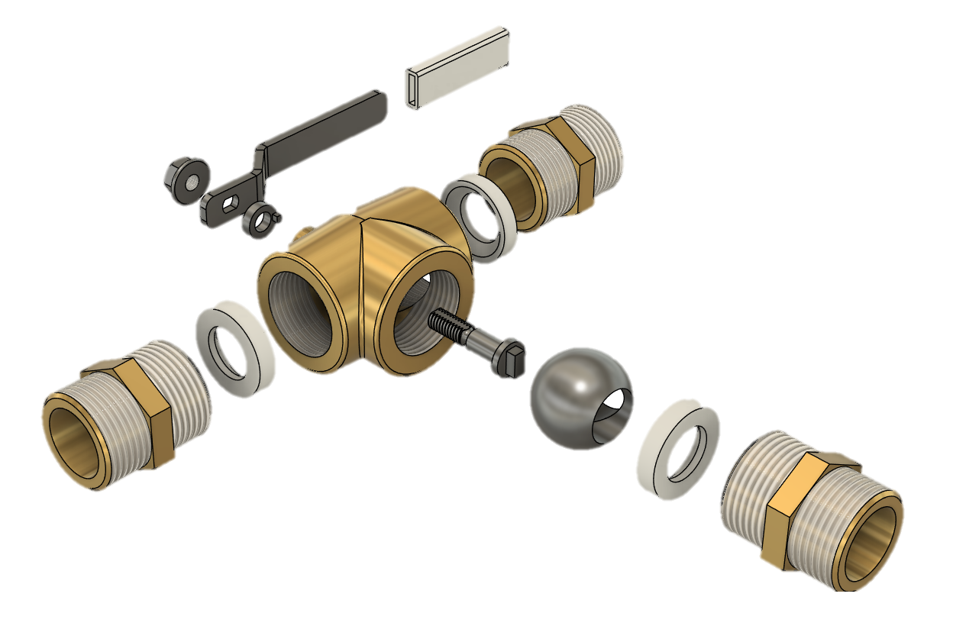

Pag. 66 | 68
SOURCE
Book – 'Mechanical Technology and Manufacturing Studies'
Marco Santochi, Francesco Giusti
HSS DIN 345 Taper Shank Drill Bit Krino Morse - ø 24.0 mm:
https://www.toolshopitalia.it/shop/punte-hss/punta-trapano-hss-din-345-codolo-conico-krino-morse-o-mm-24-0?utm_source=google&utm_medium=cpc&utm_campaign=PMax%3A%20Shopping%20Intelligente&utm_id=18034684784&gad_source=1&gad_campaignid=17339599657&gbraid=0AAAAADPjOARg8axyv7VyLBCq-hRrEWNI8&gclid=CjwKCAjw6s7CBhACEiwAuHQckqQKzImQgRPpvEQrvydoGTCVHt9Q-5C3iFW-GKMpw73kJBBa7qtM1BoCINgQAvD_BwE
Twist Drill Bit Sharpener:
https://www.fervi.com/ita/macchine-utensili-e-accessori/macchine-lavorazioni-meccaniche/affilatrici/affilatrice-per-punte-elicoidali-pr-12146.htm
Standard Length Metal Drill Bit PRO Metal HSS-G:
https://www.bosch-professional.com/it/it/punta-per-metallo-lunghezza-standard-pro-metal-hss-g-3089835-ocs-ac/
Center Drill Bit:
https://www.fervi.com/ita/utensili-da-taglio/punte-e-frese-da-metallo/punte-coniche-e-da-centro/punta-da-centro-pr-5538.htm
C Machine Reamer HSCO WN, H7 Universal:
https://eshop.wuerth.it/Alesatore-per-macchina-NC-HSCO-WN-H7-Universale-ALESATORE-HSCO-WN-H7-D60-L93-26/0620100600.sku/it/IT/EUR/
Machine Reamer:
https://www.fervi.com/ita/utensili-da-taglio/punte-e-frese-da-metallo/alesatori-a-macchina/alesatore-a-macchina-pr-5668.htm
Machine Tap 6131 G 3/4 GAS WSG HSS-E for Blind and Through Holes with Through Shank:
https://www.ferramentaparide.it/treviso-industria/treviso-punte-frese-maschi-filiere/treviso-maschi-per-filettatura-gas/treviso-maschio-a-macchina-6131-g-34-gas-wsg-hss-e-per-fori-ciechi-e-passanti-gambo-passante-wsg
Chrome-plated Brass Nipple 3/4'' 8000 Series M
https://www.tecnomat.it/it/nipple-ottone-cromato-3-4-12088318/
Pag. 67 | 68
M6 Hex Flanged Nut RS PRO, Stainless Steel:
https://it.rs-online.com/web/p/dadi-esagonali/7259640?cm_mmc=IT-PLA-DS3A-_-google-_-CSS_IT_IT_PMAX_RS+PRO-_--_-7259640&matchtype=&&gad_source=1&gad_campaignid=20706533254&gbraid=0AAAAADkeWNOmmH-ZaA7pnN8rN7wyNKu4q&gclid=CjwKCAjw3_PCBhA2EiwAkH_j4ooiMRvMtfjc8gzG6AIdMXEy0JwAe7aPAY4p6BnJ3rYoBl6OfZMamBoCYMMQAvD_BwE&gclsrc=aw.ds
Source for Tools and Turning Inserts:
https://www.sandvik.coromant.com/it-it
https://www.hoffmann-group.com/GR/el/pangakis/p/202976-4
HBM Industrial Metal Lathe 360 x 1000 Complete with Wide Through-Hole and 3-Axis LCD Digital Readout System - 400 Volt:
https://www.hbm-machines.com/it/p/tornio-industriale-hbm-360-x-1000-completo-di-grande-passaggio-e-sistema-di-lettura-digitale-lcd-3-assi-400-volt
HBM Professional 32 mm Column Drill Floor Model - 230 Volt:
https://www.hbm-machines.com/it/p/hbm-32-mm-macchina-da-perforazione-professionale-a-pavimento-230-volt?sku=7867
HBM BF 45 Profi Milling Machine with 3-Axis LCD Digital Readout System - 400 Volt:
https://www.hbm-machines.com/it/p/fresatrice-hbm-bf-45-profi-con-sistema-di-lettura-digitale-lcd-a-3-assi-400-volt?sku=00213#description
AISI 304 Stainless Steel Round Bar Ground - Ø 10 mm:
https://www.plexishop.it/it/metalli/acciaio-inossidabile/barra-tonda-in-acciaio-inox-aisi-304-rettificata-o-10-mm.html?srsltid=AfmBOooVxPb4vlAJLFXTkuxNAURorJMAk7dpKwIAB5k1r2YHobrjhC82

Pag. 68 | 68

